# General

Neural Network,

Sigmog in each node $→$ can model non-linear, complex function, based on decreasing error $→$ used for classification.

## [10707 Deep Learning Russ Salakhutdinov](https://www.cs.cmu.edu/~rsalakhu/10707/Lectures/Lecture_NN_Part1.pdf)

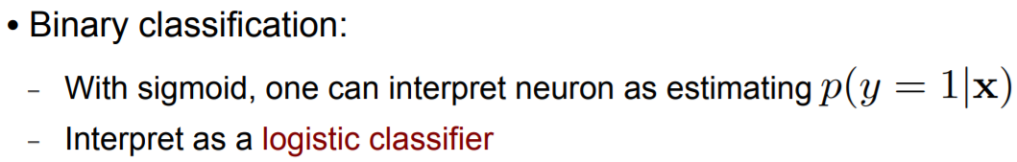

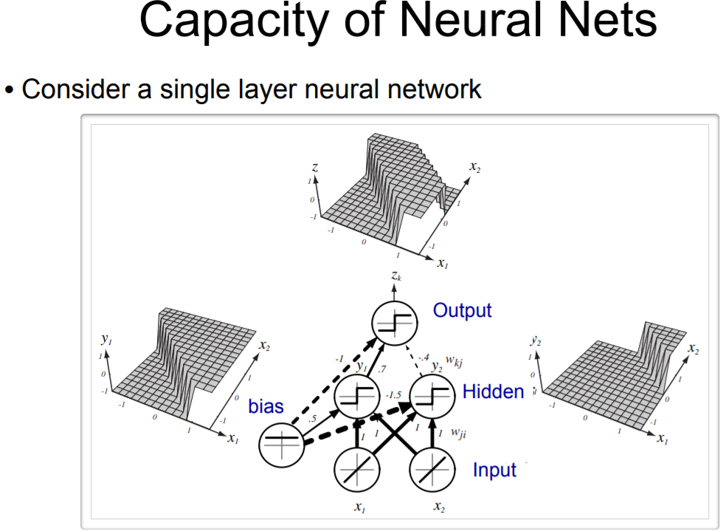 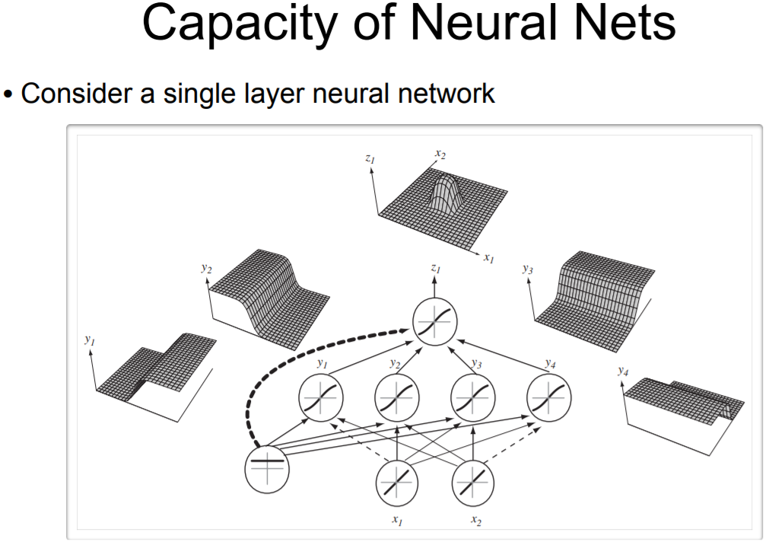

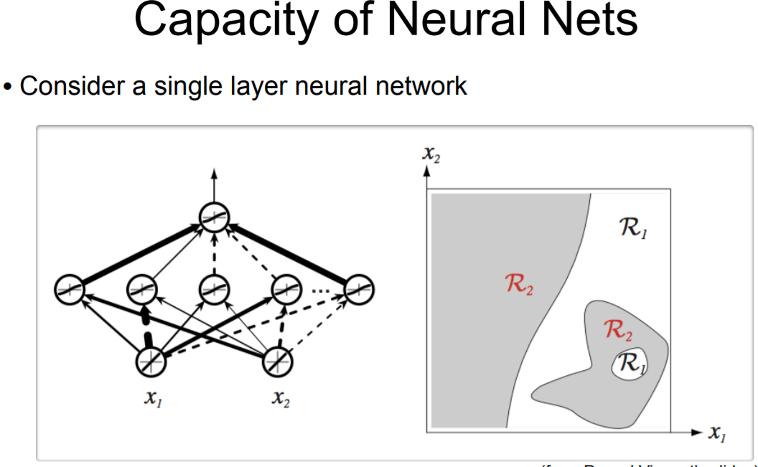 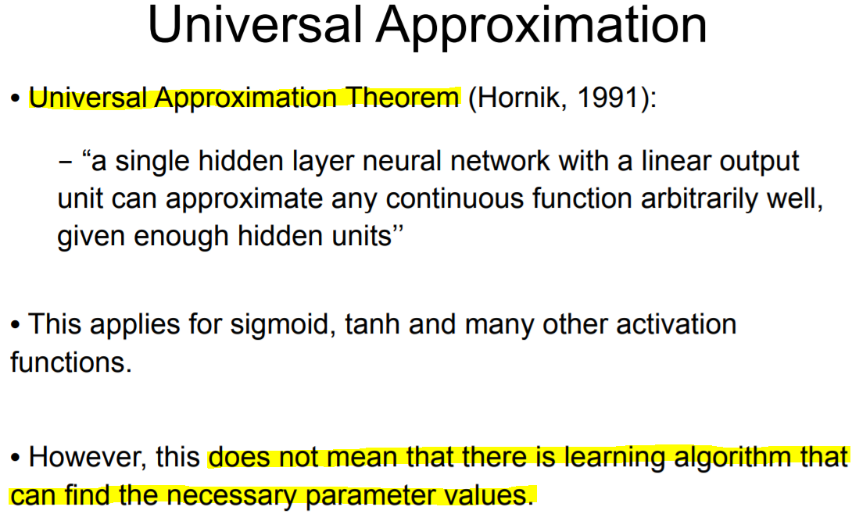

## [Analytics Vidhya – Best Resources on Machine Learning, Deep Learning, Neural Networks](https://www.analyticsvidhya.com/resources-machine-learning-deep-learning-neural-networks/)

1. [**Step by Step Learning Path on Machine Learning**](https://www.analyticsvidhya.com/learning-path-learn-machine-learning/)

…

**Step 2: Data Exploration / Cleaning / Preparation**

What differentiates a good machine learning professional from an average one is the quality of feature engineering and data cleaning which happens on the original data. The more quality time you spend here, the better it is. This step also takes the bulk of your time and hence it helps to put a structure around it. You can refer series of articles below to learn different stages of data explorations.

1. [Variable Identification, Univariate and Multivariate analysis](https://www.analyticsvidhya.com/blog/2015/02/data-exploration-preparation-model/)
2. [Missing values treatment](https://www.analyticsvidhya.com/blog/2015/02/7-steps-data-exploration-preparation-building-model-part-2/)
3. [Outlier treatment](https://www.analyticsvidhya.com/blog/2015/02/outliers-detection-treatment-dataset/)
4. [Feature Engineering](https://www.analyticsvidhya.com/blog/2015/03/feature-engineering-variable-transformation-creation/)

You can also refer Data exploration methods in R and Python:

* [Data Exploration in R](https://www.analyticsvidhya.com/blog/2015/04/comprehensive-guide-data-exploration-r/)
* [Data Exploration in Python](https://www.analyticsvidhya.com/blog/2015/04/comprehensive-guide-data-exploration-sas-using-python-numpy-scipy-matplotlib-pandas/)

**Exercise / assignment:**

1. Take up the titanic survival problem from Kaggle, build a set of hypothesis and then clean the data, add new features to the existing dataset. Think what is the best way to impute missing age?
2. Similarly, take up the Bike sharing demand forecasting problem and repeat the cycle mentioned above.

…

**Step 5: Advanced Machine Learning**

…

* The most comprehensive resource is [deeplearning.net](http://deeplearning.net/). You will find everything here – lectures, datasets, challenges, tutorials.
* Another [course from Geoff Hinton](https://www.coursera.org/course/neuralnets) a try in a bid to understand the basics of Neural Networks
* Pattern recognition using Python ([Resource 1](http://pythonvision.org/basic-tutorial/), [Resource 2](http://bytefish.de/pdf/facerec_python.pdf), [Resource 3](https://www.analyticsvidhya.com/blog/2014/12/image-processing-python-basics/)) and R ([Resource 1](http://www.bioconductor.org/packages/release/bioc/vignettes/EBImage/inst/doc/EBImage-introduction.pdf))
* Text Mining using Python ([Resource](https://www.analyticsvidhya.com/blog/2014/11/text-data-cleaning-steps-python/)) and R ([Resource 1](https://rstudio-pubs-static.s3.amazonaws.com/31867_8236987cf0a8444e962ccd2aec46d9c3.html), [Resource 2](https://deltadna.com/blog/text-mining-in-r-for-term-frequency/))

**Ensemble modeling**

This is where an expert is different from an average professional. Ensembling can add a lot of power to your models and has been a very successful technique in various Kaggle competitions. Here is one of the [best guide on emsemble modeling](http://mlwave.com/kaggle-ensembling-guide/) we have come across.

## [Analytics Vidhya – Fundamentals of Deep Learning – Activation Functions and When to Use Them?](https://www.analyticsvidhya.com/blog/2017/10/fundamentals-deep-learning-activation-functions-when-to-use-them/)

When our brain is fed with a lot of information simultaneously, it tries hard to understand and classify the information between useful and not-so-useful information. We need a similar mechanism to classify incoming information as useful or less-useful in case of Neural Networks.

This is a very important in the way a network learns because not all information is equally useful. Some of it is just noise. Well, activation functions help the network do this segregation. They help the network use the useful information and suppress the irrelevant data points.

**What is an Activation Function?**

They basically decide whether a neuron should be activated or not. Whether the information that the neuron is receiving is relevant for the given information or should it be ignored.



The activation function is the non linear transformation that we do over the input signal. This transformed output is then sent to the next layer of neurons as input.

**Can we do without an activation function?**

If the activation function increases the complexity so much, can we do without an activation function?

When we do not have the activation function the weights and bias would simply do a linear transformation. A linear equation is simple to solve but is limited in its capacity to solve complex problems. A neural network without an activation function is essentially just a linear regression model.

The activation function does the non-linear transformation to the input making it capable to learn and perform more complex tasks. We would want our neural networks to work on complicated tasks like language translations and image classifications.

Activation functions make the back-propagation possible since the gradients are supplied along with the error to update the weights and biases. Without the differentiable non linear function, this would not be possible.

**Popular types of activation functions and when to use them**

*Binary Step Function*

The first thing that comes to our mind when we have an activation function would be a threshold based classifier i.e. whether or not the neuron should be activated. If the value Y is above a given threshold value then activate the neuron else leave it deactivated.

f(x) = 1, x>=0

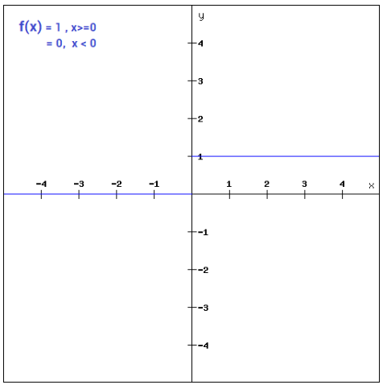

The function is more theoretical than practical since in most cases we would be classifying the data into multiple classes than just a single class. The step function would not be able to do that.

Moreover, The gradient of the step function is zero. This makes the step function not so useful since during back-propagation when the gradients of the activation functions are sent for error calculations to improve and optimize the results. The gradient of the step function reduces it all to zero and improvement of the models doesn’t really happen.

f '(x) = 0, for all x

*Linear Function*

Instead of a simple step function, we can try using a linear function.

f(x)=ax

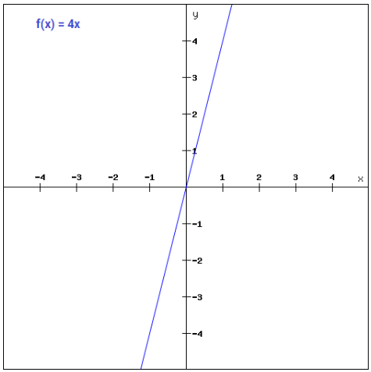

This can be applied to various neurons and multiple neurons can be activated at the same time. Now, when we have multiple classes, we can choose the one which has the maximum value. But we still have an issue here. Let’s look at the derivative of this function.

f'(x) = a

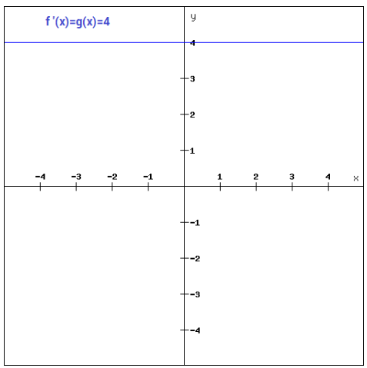

The derivative of a linear function is constant i.e. it does not depend upon the input value x.

This means that every time we do a back propagation, the gradient would be the same. And this is a big problem, we are not really improving the error since the gradient is pretty much the same.

*Sigmoid*

Sigmoid is a widely used activation function.

f(x)=1/(1+e^-x)

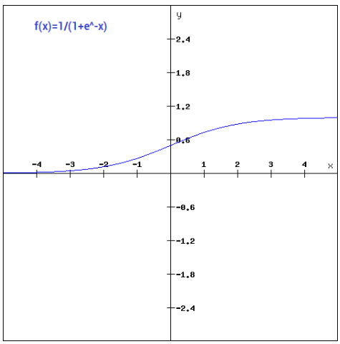

This is a smooth function and is continuously differentiable. The biggest advantage that it has over step and linear function is that it is non-linear. This essentially means that when I have multiple neurons having sigmoid function as their activation function – the output is non linear as well.

The gradient is very high between the values of -3 and 3 but gets much flatter in other regions. How is this of any use? This means that in this range small changes in x would also bring about large changes in the value of Y. So the function essentially tries to push the Y values towards the extremes. This is a very desirable quality when we’re trying to classify the values to a particular class.

Let’s take a look at the gradient of the sigmoid function as well.

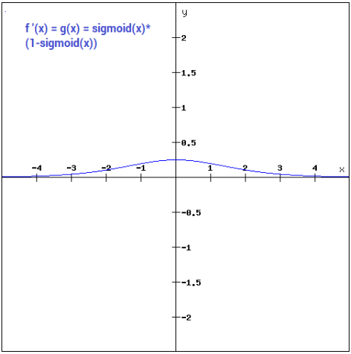

It’s smooth and is dependent on x. This means that during backpropagation we can easily use this function. The error can be backpropagated and the weights can be accordingly updated.

Sigmoids are widely used even today but we still have a problems that we need to address. As we saw previously – the function is pretty flat beyond the +3 and -3 region. This means that once the function falls in that region the gradients become very small. This means that the gradient is approaching to zero and the network is not really learning.

Another problem that the sigmoid function suffers is that the values only range from 0 to 1. This means that the sigmoid function is not symmetric around the origin and the values received are all positive. So not all times would we desire the values going to the next neuron to be all of the same sign. This can be addressed by scaling the sigmoid function. That’s exactly what happens in the tanh function.

*Tanh*

A scaled version of the sigmoid function.

tanh(x)=2sigmoid(2x)-1

It can be directly written as –

tanh(x)=2/(1+e^(-2x)) -1

Tanh works similar to the sigmoid function but is symmetric over the origin. it ranges from -1 to 1.

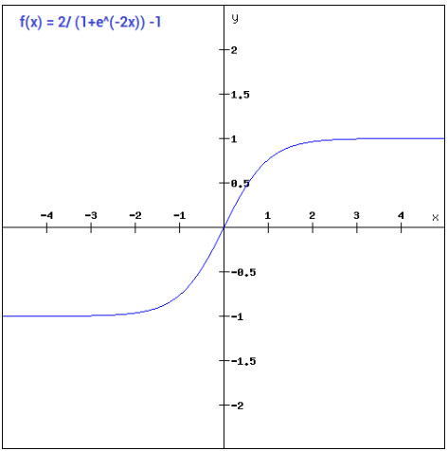

It basically solves our problem of the values all being of the same sign. All other properties are the same as that of the sigmoid function.

Let’s have a look at the gradient of the tanh function:

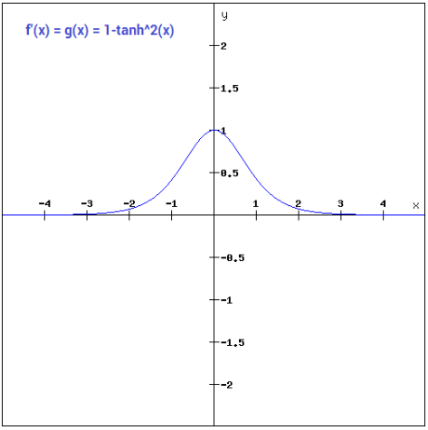

The gradient of the tanh function is steeper as compared to the sigmoid function. Our choice of using sigmoid or tanh would basically depend on the requirement of gradient in the problem statement. But similar to the sigmoid function we still have the vanishing gradient problem.

*ReLU*

The ReLU function is the Rectified linear unit. It is the most widely used activation function:

f(x)=max(0,x)

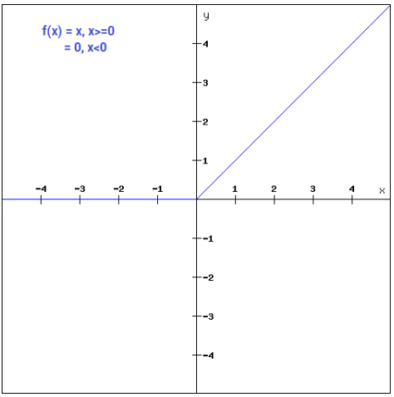

The ReLU function is non linear, which means we can easily backpropagate the errors and have multiple layers of neurons being activated by the ReLU function.

The main advantage of using the ReLU function over other activation functions is that it does not activate all the neurons at the same time. What does this mean ? If you look at the ReLU function if the input is negative it will convert it to zero and the neuron does not get activated. This means that at a time only a few neurons are activated making the network sparse making it efficient and easy for computation.

Let’s look at the gradient of the ReLU function.

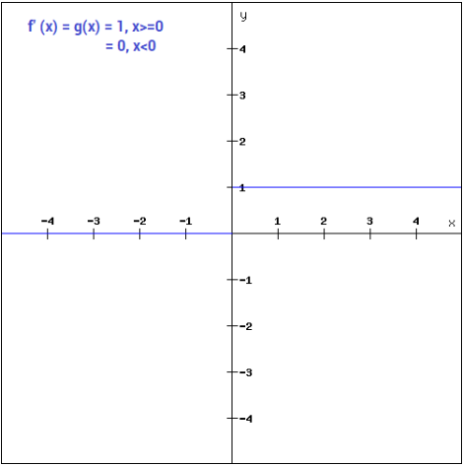

But ReLU also falls a prey to the gradients moving towards zero. If you look at the negative side of the graph, the gradient is zero, which means for activations in that region, the gradient is zero and the weights are not updated during back propagation. This can create dead neurons which never get activated. When we have a problem, we can always engineer a solution.

*Leaky ReLU*

Leaky ReLU function is nothing but an improved version of the ReLU function. As we saw that for the ReLU function, the gradient is 0 for x<0, which made the neurons die for activations in that region.

It can be defined as-

f(x)= ax, x<0

= x, x>=0

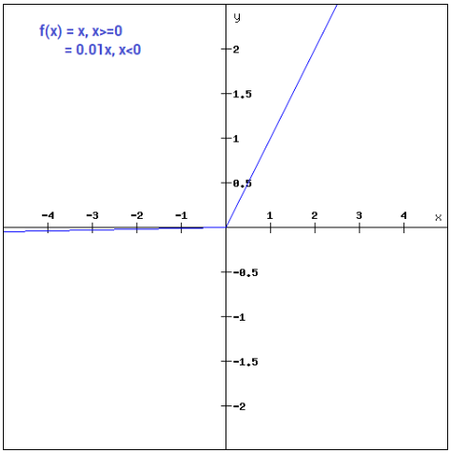

The main advantage of replacing the horizontal line is to remove the zero gradient. So in this case the gradient of the left side of the graph is non zero and so we would no longer encounter dead neurons in that region.

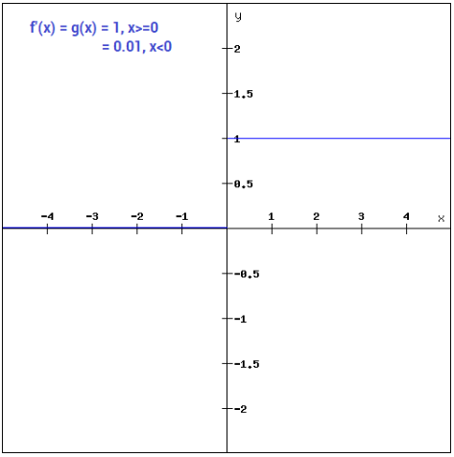

Similar to the Leaky ReLU function, we also have the **Parameterised ReLU function**. It is defined similar to the Leaky ReLU as –

f(x)= ax, x<0

= x, x>=0

However, in case of a parameterised ReLU function, ‘**a**‘ is also a trainable parameter. The network also learns the value of ‘**a**‘ for faster and more optimum convergence. The parametrised ReLU function is used when the leaky ReLU function still fails to solve the problem of dead neurons and the relevant information is not successfully passed to the next layer.

*Softmax*

The softmax function is also a type of sigmoid function but is handy when we are trying to handle classification problems. …

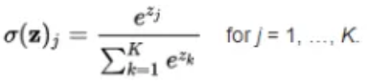

The softmax function is ideally used in the output layer of the classifier where we are actually trying to attain the probabilities to define the class of each input.

**Choosing the right Activation Function**

* Sigmoid functions and their combinations generally work better in the case of classifiers
* Sigmoids and tanh functions are sometimes avoided due to the vanishing gradient problem
* ReLU function is a general activation function and is used in most cases these days
* If we encounter a case of dead neurons in our networks the leaky ReLU function is the best choice
* Always keep in mind that ReLU function should only be used in the hidden layers
* As a rule of thumb, you can begin with using ReLU function and then move over to other activation functions in case ReLU doesn’t provide with optimum results

[**TDS – Machine Learning for Beginners: An Introduction to Neural Networks**](https://towardsdatascience.com/machine-learning-for-beginners-an-introduction-to-neural-networks-d49f22d238f9)

**1. Building Blocks: Neurons**

A neuron takes inputs, does some math with them, and produces one output. Here’s what a 2-input neuron looks like:

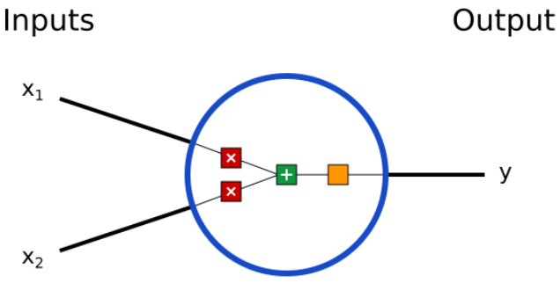

* First, each input is multiplied by a weight:

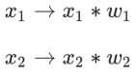

* Next, all the weighted inputs are added together with a bias b:

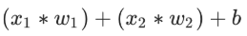

* Finally, the sum is passed through an activation function:

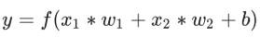

The activation function is used to turn an unbounded input into an output that has a nice, predictable form. A commonly used activation function is the [sigmoid](https://en.wikipedia.org/wiki/Sigmoid_function) function.

The sigmoid function only outputs numbers in the range (0,1). You can think of it as compressing (−∞,+∞) to (0,1) — big negative numbers become ~0, and big positive numbers become ~1.

**A Simple Example** …

The process of passing inputs forward to get an output is known as **feedforward**.

**Coding a Neuron** …

**2. Combining Neurons into a Neural Network**

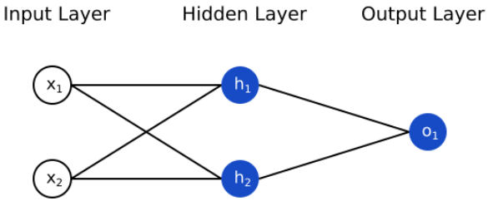

**An Example: Feedforward** …

**Coding a Neural Network: Feedforward** …

**3. Training a Neural Network, Part 1**

**Loss** …

**4. Training a Neural Network, Part 2**

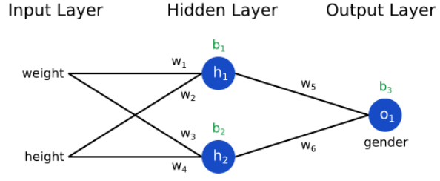

Then, we can write loss as a multivariable function:

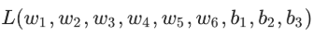

Imagine we wanted to tweak *w*1​. How would loss *L* change if we changed *w*1​? That’s a question the [partial derivative](https://simple.wikipedia.org/wiki/Partial_derivative) can answer. How do we calculate it?

To start, let’s rewrite the partial derivative in terms of ∂*y_pred/*∂*w*1:

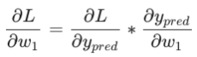

…

We’ve managed to break down ∂*L/*∂*w*1​ into several parts we can calculate:

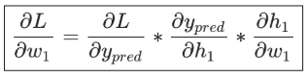

This system of calculating partial derivatives by working backwards is known as **backpropagation**, or “backprop”.

…

**Training: Stochastic Gradient Descent**

We have all the tools we need to train a neural network now! We’ll use an optimization algorithm called [stochastic gradient descent](https://en.wikipedia.org/wiki/Stochastic_gradient_descent) (SGD) that tells us how to change our weights and biases to minimize loss. It’s basically just this update equation:

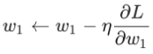

*η* is a constant called the **learning rate** that controls how fast we train. All we’re doing is subtracting *η*∂*w*1/​∂*L*​ from *w*1​:

* If ∂*L/*∂*w*1​ is positive, *w*1​ will decrease, which makes *L* decrease.
* If ∂*L/*∂*w*1​​ is negative, *w*1​ will increase, which makes *L* decrease.

If we do this for every weight and bias in the network, the loss will slowly decrease and our network will improve.

Our training process will look like this:

1. Choose **one** sample from our dataset. This is what makes it *stochastic*gradient descent — we only operate on one sample at a time.
2. Calculate all the partial derivatives of loss with respect to weights or biases (e.g. ∂*L/*∂*w*1​, ∂*L*​/∂*w*2​, etc).
3. Use the update equation to update each weight and bias.
4. Go back to step 1.

…

## [bouvet - An Introduction to Deep Learning](https://www.bouvet.no/bouvet-deler/an-introduction-to-deep-learning)

**Types of Deep Learning Architectures**

Many Deep Learning Architectures exist. These are all based on ANNs, but have specific optimatisations that make them good for certain use cases. Some examples:

* **Multi Layer Perception (MLPs)**: MLPs are a type of Feed Forward ANN where all nodes are in a given layer are connected to all the nodes in the next layer, and so on. They are perfom well for classification and regression, but the sheer amount of connections (and their accompanying weights) mean that MLPs demand a lot of processing power for relatively simple tasks.
* **Convolutional Neural Networks (CNNs)**: The most popular solution for Image Processing due to their ability to handle spatial data, CNNs also have a more efficient structure and require less processing power than MLPs.
* **Recurrent Neural Networks (RNNs)**: These are built for sequential data and are therefore popular for Natural Language Processing.
* **Hybrid Models**: Combining different type of ANNs can unlock complex use cases, such as combining CNN and RNN to process a sequence of images or frames in a video stream.

…

Q: DO YOU NEED INSIGHT TO WHY YOUR DEEP LEARNING ANN MADE A SPECIFIC DECISION?

One of the weaknesses of Deep Learning is the lack of Interpretability. Deep Learning ANNs build their own feature hierarchies from the training data, based upon mathematical operations. These feature hierarchies may not be easily interpretable by humans. This can be a problem if you have to explain to a customer why your ANN rejected their application for a credit extension.

Q: DO YOU HAVE THE NECESSARY PROCESSING POWER AND DATA STORAGE AVAILABLE?

Deep Learning can be resource intensive. Not only do you need processing power for training the model, but you also need data storage for all your training data. In the era of cloud computing these problems are easily solvable, but can potentially lead to big costs.

Q: HOW WILL YOU DEPLOY YOUR DEEP LEARNING ANN TO PRODUCTION?

How will you deal with problems such as Data Drift? Do you need to retrain your ANN often? How will you monitor it's performance? Do you have a data pipeline ready? Many people forget to address these questions until it is too late.

Q: HOW WILL YOU EVALUATE YOUR DEEP LEARNING ANN?

When is your model good enough? 98% accuracy? 65%? What is your businesses acceptable margin of error?

## [Hackernoon – Illustrative Proof of Universal Approximation Theorem](https://hackernoon.com/illustrative-proof-of-universal-approximation-theorem-5845c02822f6)

…

**Modeling Complex Relations**

…

Now the question arises, how do we decide how many layers to use, how many neurons in each layer etc… these are valid questions but the discussion on these questions is out of the scope of this article.

…

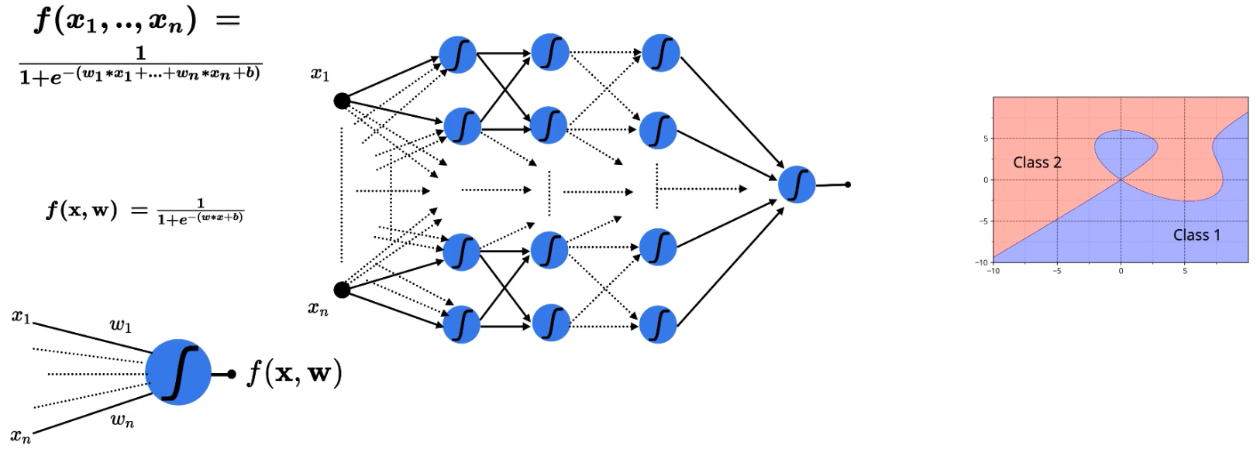

*Universal approximation theorem :* A feed-forward network with a single hidden layer containing a finite number of neurons can approximate continuous functions on compact subsets of **R**, under mild assumptions on the activation function — Wikipedia In simple terms, UAT says that — you can always come up with a deep neural network that will approximate any complex relation between input and output.

**Proof of Universal Approximation Theorem**

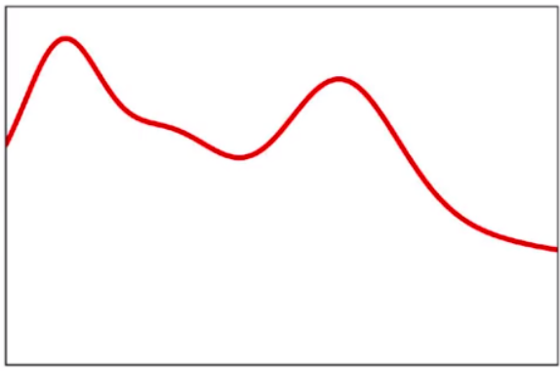

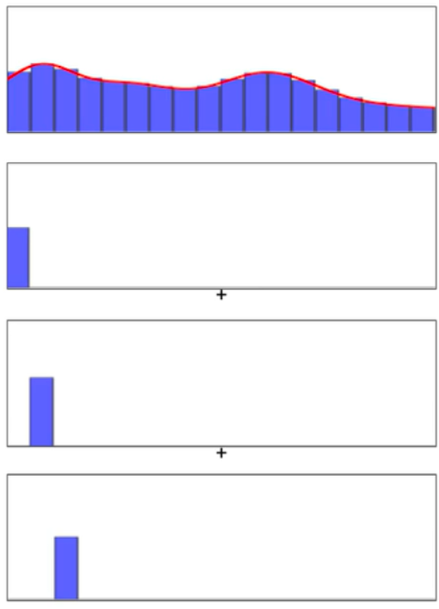

…

**Neural Network**

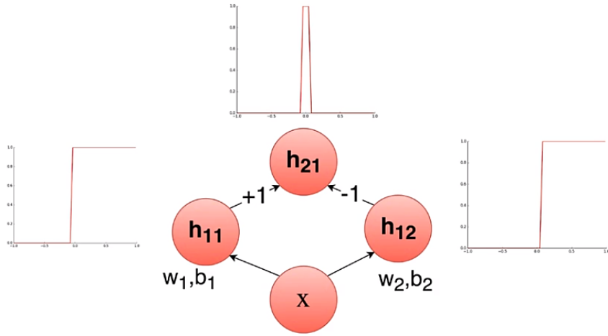

## [Hackernoon – McCulloch Pitts Neuron — Deep Learning Building Block](https://medium.com/hackernoon/mcculloch-pitts-neuron-deep-learning-building-blocks-7928f4e0504d?source=friends_link&sk=4dc5ca78a789aa891d3435e9be22f153)

The function (soma) is actually split into two parts: **g —**The aggregates the inputs to a single numeric value and the function **f**produces the output of this neuron by taking the output of the **g**as the input i,e.. a single value as its argument. The function **f**will output the value 1 if the aggregation performed by the function **g** is greater than some threshold else it will return 0.

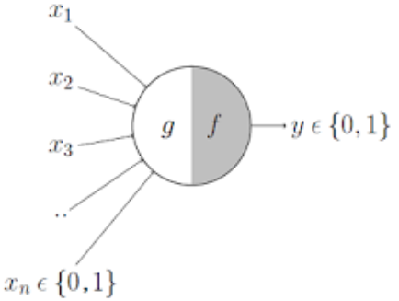

The inputs x1, x2, ….. xn for the MP Neuron can only take boolean values and the inputs can be inhibitory or excitatory.

…

## [Hackernoon – Perceptron –  Deep Learning Basics](https://hackernoon.com/perceptron-deep-learning-basics-3a938c5f84b6)

An upgrade to McCulloch-Pitts Neuron.

*Perceptron*

In the MP Neuron Model, all the inputs have the same weight (same importance) while calculating the outcome and the parameter **b** (threshold) can only take fewer values i.e., the parameter space for finding the best parameter is limited.

The proposed perceptron model introduces the concept of weights to the inputs and also devised an algorithm to find these numerical parameters.

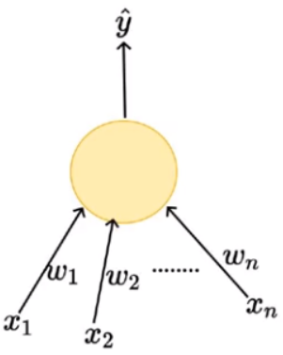

In perceptron model inputs can be real numbers unlike the boolean inputs in MP Neuron Model.

The output from the model still is boolean outputs {0,1}.

*Mathematical Representation*

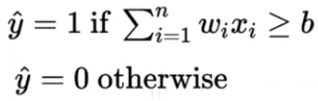

The function here has two parameters weights:

* **W** (w1,w2,....,wn)
* threshold **b**.

w1x1+w2x2-b = 0 (In 2D)  
w1x1+w2x2+w3x3-b = 0 (In 3D)

…

*Loss Function*

The loss function value will be zero if the Yactual and Ypredicted are equal else it will be 1. This can be represented using an indicator variable, value of the variable will be 1 if Yactual and Ypredicted are not equal else it will be 0.

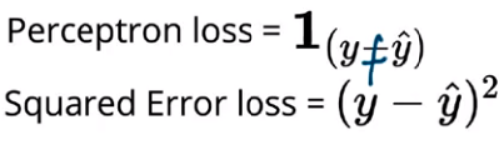

The main goal of the learning algorithm is to find vector **w**capable of absolutely separating both sets of data. Training data contains two sets of inputs, P (Positive y = 1) and N (Negative y = 0). Perceptron learning algorithm goes like this,

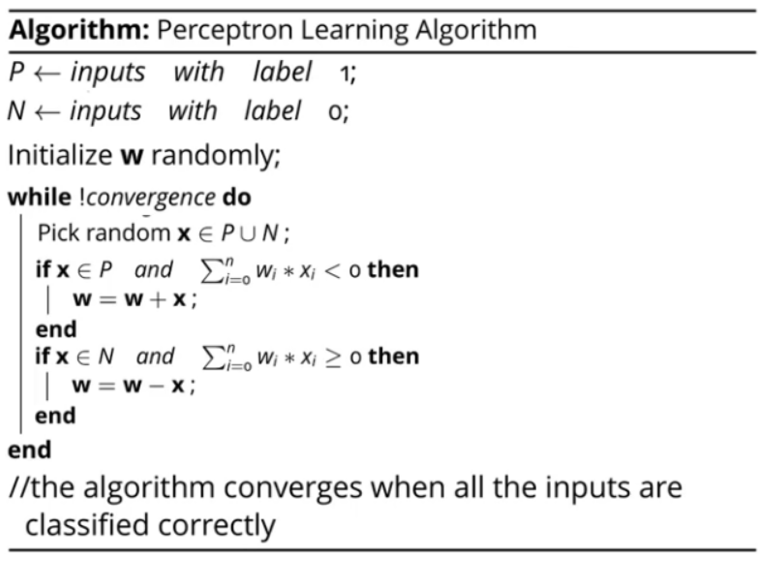

We initialize the weights randomly, then pick a random observation **x** from the entire data. If the **x** belongs to the positive class and the dot product **w.x < 0** it means that the model is making an error (we need the output to be **w.x ≥ 0** for positive class refer Fig — 6) and the weights need to be updated (**w = w + x**). Similarly, if the **x** belongs to the negative class and the dot product **w.x ≥ 0** (we need the output to be **w.x < 0** for negative class) again in this case the model made an error, so the weights need to be updated (**w = w — x**). We will continue this operation till we reach convergence, convergence in our case means that our model is able to classify all the inputs correctly.

*The intuition behind the Learning Algorithm*

Now we will see why updating the weights (adding or subtracting) helps us to classify positive and negative classes perfectly.

The cosine angle between the two vectors **w**and **u** is given by

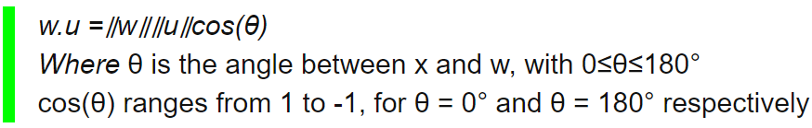

The important point to note from the cosine formula is that the sign of the cosine angle depends on the dot product.

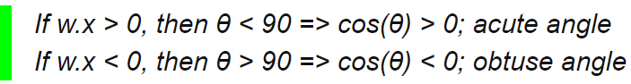

For all observations **x** belongs to positive input space **P,**we want the **w.x ≥ 0** that means the angle between the two vectors **w** and **x** should be less than 90. In case there is a miss-classification, we are updating the parameters by adding the **x**to **w**. Essentially we are increasing the cosine angle between **w** and **x** (why? See below?), if the cosine angle is increasing that means the angle between vectors decreases from obtuse to acute, which is what we wanted.

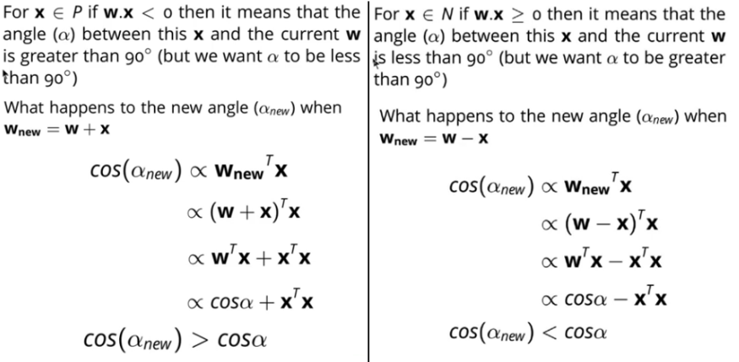

**Model Evaluation**

…

## [Stack Exchange - How to choose the number of hidden layers and nodes in a feedforward neural network?](https://stats.stackexchange.com/questions/181/how-to-choose-the-number-of-hidden-layers-and-nodes-in-a-feedforward-neural-netw)

**The Output Layer**

Like the Input layer, every NN has *exactly one* output layer. Determining its size (number of neurons) is simple; it is completely determined by the chosen model configuration.

Is your NN going running in *Machine* Mode or *Regression* Mode (the ML convention of using a term that is also used in statistics but assigning a different meaning to it is very confusing). Machine mode: returns a class label (e.g., "Premium Account"/"Basic Account"). Regression Mode returns a value (e.g., price).

If the NN is a regressor, then the output layer has a single node (You can definitely have multiple continuous outputs if your target output is vector-valued).

If the NN is a classifier, then it also has a single node unless *softmax* is used in which case the output layer has one node per class label in your model.

**The Hidden Layers**

How many hidden layers? Well if your data is linearly separable (which you often know by the time you begin coding a NN) then you don't need any hidden layers at all (output layer will do the job). Of course, you don't need an NN to resolve your data either, but it will still do the job.

One issue within this subject on which there is a consensus is the performance difference from adding additional hidden layers: the situations in which performance improves with a second (or third, etc.) hidden layer are very few.

***One hidden layer is sufficient for the large majority of problems.***

So what about size of the hidden layer(s)--how many neurons? There are some empirically-derived rules-of-thumb, of these, the most commonly relied on is

**'*the optimal size of the hidden layer is usually between the size of the input and size of the output layers*'.**

In sum, for most problems, one could probably get decent performance (even without a second optimization step) by setting the hidden layer configuration using just two rules: (i) number of hidden layers equals one; and (ii) the number of neurons in that layer is the mean of the neurons in the input and output layers.

**Optimization of the Network Configuration**

***Pruning*** describes a set of techniques to trim network size (by nodes not layers) to improve computational performance and sometimes resolution performance. The gist of these techniques is removing nodes from the network during training by identifying those nodes which, if removed from the network, would not noticeably affect network performance (i.e., resolution of the data). (Even without using a formal pruning technique, you can get a rough idea of which nodes are not important by looking at your weight matrix after training; look weights very close to zero--it's the nodes on either end of those weights that are often removed during pruning.) Obviously, if you use a pruning algorithm during training then begin with a network configuration that is more likely to have excess (i.e., 'prunable') nodes--in other words, when deciding on a network architecture, err on the side of more neurons, if you add a pruning step.

Put another way, by applying a pruning algorithm to your network during training, you can approach optimal network configuration; whether you can do that in a single "up-front" (such as a genetic-algorithm-based algorithm) I don't know, though I do know that for now, this two-step optimization is more common.

…..

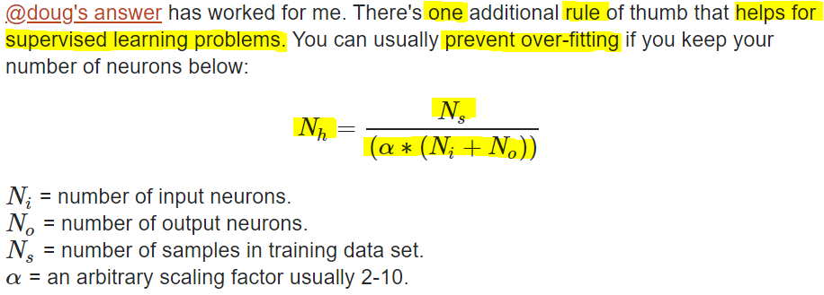

[Others recommend](http://www.solver.com/training-artificial-neural-network-intro) setting alpha to a value between 5 and 10, but I find a value of 2 will often work without overfitting. You can think of alpha as the effective branching factor or number of nonzero weights for each neuron. Dropout layers will bring the "effective" branching factor way down from the actual mean branching factor for your network.

As explained by this [excellent NN Design text](http://hagan.okstate.edu/NNDesign.pdf#page=469), you want to limit the number of free parameters in your model (its [degree](https://stats.stackexchange.com/q/57027/15974) or number of nonzero weights) to a small portion of the degrees of freedom in your data. The degrees of freedom in your data is the number samples * degrees of freedom (dimensions) in each sample or Ns∗(Ni+No) (assuming they're all independent). So α is a way to indicate how general you want your model to be, or how much you want to prevent overfitting.

For an automated procedure you'd start with an alpha of 2 (twice as many degrees of freedom in your training data as your model) and work your way up to 10 if the error (loss) for your training dataset is significantly smaller than for your test dataset.

…..

Problems that require two hidden layers are rarely encountered. However, neural networks with two hidden layers can represent functions with any kind of shape. There is currently no theoretical reason to use neural networks with any more than two hidden layers. In fact, for many practical problems, there is no reason to use any more than one hidden layer. Table 5.1 summarizes the capabilities of neural network architectures with various hidden layers.

| Number of Hidden Layers | Result |

0 - Only capable of representing linear separable functions or decisions.

1 - Can approximate any function that contains a continuous mapping from one finite space to another.

2 - Can represent an arbitrary decision boundary to arbitrary accuracy with rational activation functions and can approximate any smooth mapping to any accuracy.

Deciding the number of hidden neuron layers is only a small part of the problem.

Number of neuron? Too small -> Under fit, Too large? -> Over fit or take long time to train.

There are many rule-of-thumb methods for determining the correct number of neurons to use in the hidden layers, such as the following:

* The number of hidden neurons should be between the size of the input layer and the size of the output layer.
* The number of hidden neurons should be 2/3 the size of the input layer, plus the size of the output layer.
* The number of hidden neurons should be less than twice the size of the input layer.

These three rules provide a starting point for you to consider. Ultimately, the selection of an architecture for your neural network will come down to trial and error. But what exactly is meant by trial and error? You do not want to start throwing random numbers of layers and neurons at your network. To do so would be very time consuming. Chapter 8, “Pruning a Neural Network” will explore various ways to determine an optimal structure for a neural network.

“In order to secure the ability of the network to generalize the number of nodes has to be kept as low as possible.”

…

My advice would be to use a "large" network and regularisation, if you use regularisation then the network architecture becomes less important (provided it is large enough to represent the underlying function we want to capture), but you do need to tune the regularisation parameter properly.

However, this is all subject to the "no free lunch" theorems, while regularisation is effective in most cases, there will always be cases where architecture selection works better, and the only way to find out if that is true of the problem at hand is to try both approaches and cross-validate.

## [TDS – Sigmoid Neuron — Building Block of Deep Neural Networks](https://towardsdatascience.com/sigmoid-neuron-deep-neural-networks-a4cd35b629d7)

The building block of the deep neural networks is called the sigmoid neuron.

Sigmoid neurons are similar to perceptrons, but they are slightly modified such that the output from the sigmoid neuron is much smoother than the step functional output from perceptron.

**Why Sigmoid Neuron**

Let's talk about the perceptron model and its limitations.

Perceptron model takes several real-valued inputs and gives a single binary output.

…

Red points indicates that person would not buy a car and green points indicates that person would like to buy a car. Isn’t it a bit odd that a person with 50.1K will buy a car but someone with a 49.9K will not buy a car? The small change in the input to a perceptron can sometimes cause the output to completely flip, say from 0 to 1. It is a characteristic of the perceptron neuron itself which behaves like a step function. We can overcome this problem by introducing a new type of artificial neuron called a *sigmoid* neuron.

**Sigmoid Neuron**

In the sigmoid neuron, a small change in the input only causes a small change in the output as opposed to the stepped output. The most commonly used function is the logistic function.

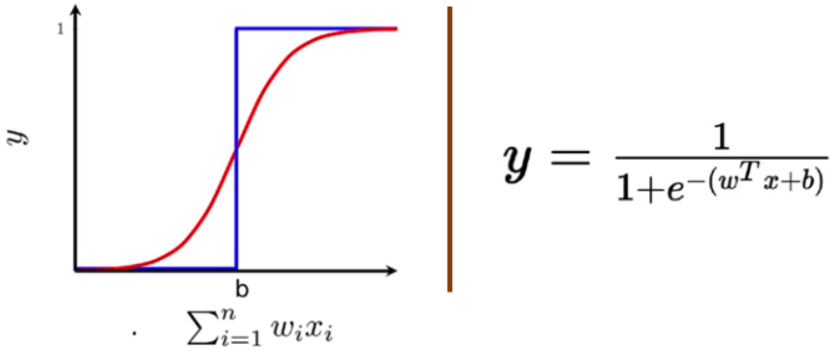

The output from the sigmoid neuron is not 0 or 1. Instead, it is a real value between 0–1 which can be interpreted as a probability.

**Data & Task**

*Regression and Classification*

**Learning Algorithm**

…gradient descent algorithm….

**Can It Handle Non-Linear Data?**

… As you can see the predicted value for the observation present in the far left of the plot is zero (present in the dark red region) and the predicted value of another observation is around 0.35 i.e. there is a 35% chance that the person might buy a car. Unlike the rigid output from the perceptron, now we a smooth and continuous output between 0–1 which can be interpreted as a probability.

## [TDS – The Vanishing Gradient Problem](https://towardsdatascience.com/the-vanishing-gradient-problem-69bf08b15484)

…

**Why it’s significant:**

For shallow network with only a few layers that use these activations, this isn’t a big problem. However, when more layers are used, it can cause the gradient to be too small for training to work effectively.

Gradients of neural networks are found using backpropagation. Simply put, backpropagation finds the derivatives of the network by moving layer by layer from the final layer to the initial one. By the chain rule, the derivatives of each layer are multiplied down the network (from the final layer to the initial) to compute the derivatives of the initial layers.

However, when *n* hidden layers use an activation like the sigmoid function, *n* small derivatives are multiplied together. Thus, the gradient decreases exponentially as we propagate down to the initial layers.

A small gradient means that the weights and biases of the initial layers will not be updated effectively with each training session. Since these initial layers are often crucial to recognizing the core elements of the input data, it can lead to overall inaccuracy of the whole network.

**Solutions:**

The simplest solution is to use other activation functions, such as ReLU, which doesn’t cause a small derivative.

Residual networks are another solution, as they provide residual connections straight to earlier layers….

Finally, batch normalization layers can also resolve the issue. As stated before, the problem arises when a large input space is mapped to a small one, causing the derivatives to disappear. In Image 1, this is most clearly seen at when |x| is big. Batch normalization reduces this problem by simply normalizing the input so |x| doesn’t reach the outer edges of the sigmoid function. As seen in Image 3, it normalizes the input so that most of it falls in the green region, where the derivative isn’t too small.

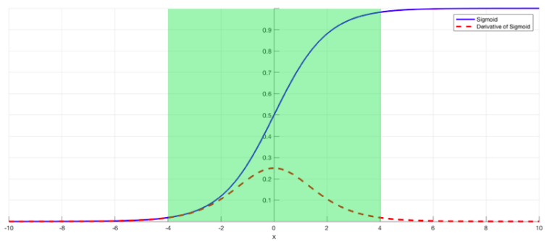

## [TDS – The mostly complete chart of Neural Networks, explained](https://towardsdatascience.com/the-mostly-complete-chart-of-neural-networks-explained-3fb6f2367464)

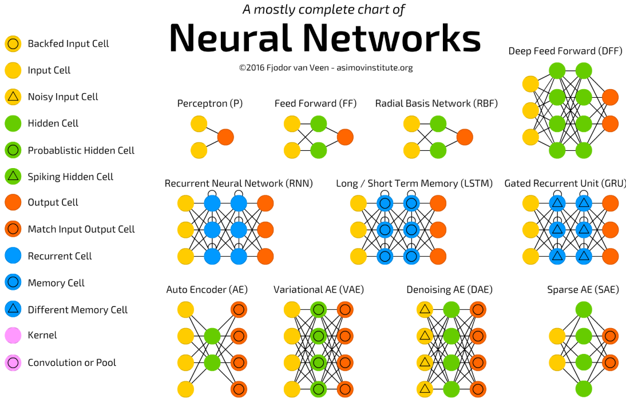

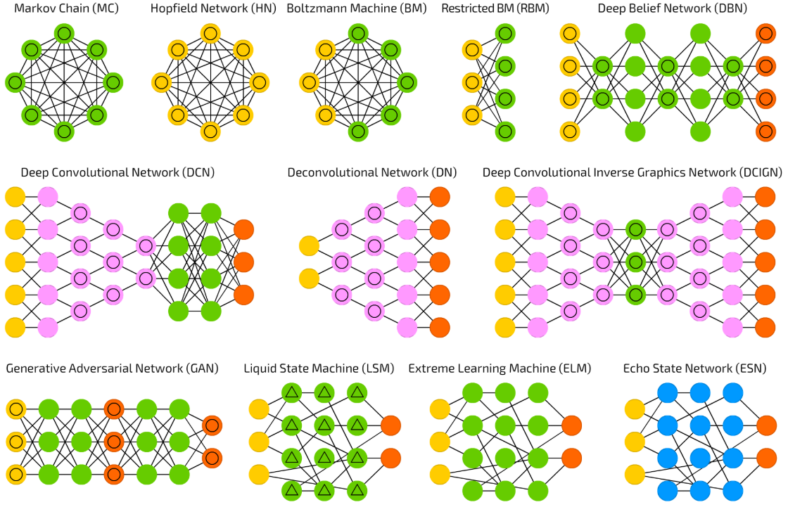

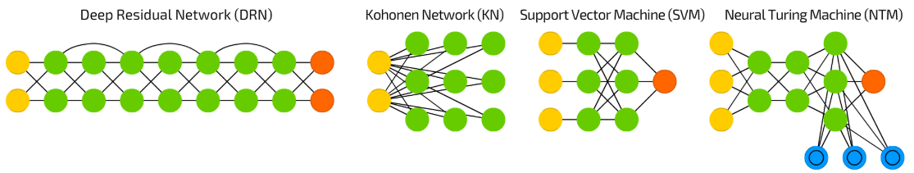

**Perceptron**. The simplest and oldest model of Neuron. Makes some inputs, sums them up, applies activation function and passes them to output layer.

**Feed forward neural networks** are also quite old — the approach originates from 50s. Generally it follows the following rules:

1. All nodes are fully connected.
2. Activation flows from input layer to output, without back loops.
3. There is one layer between input and output (hidden layer).

In most cases this type of networks is trained using [Backpropagation](https://en.wikipedia.org/wiki/Backpropagation) method.

**RBF neural networks** are actually FF (feed forward) NNs, that use [radial basis function](https://en.wikipedia.org/wiki/Radial_basis_function) as activation function instead of [logistic function](https://en.wikipedia.org/wiki/Logistic_function). Logistic function map some arbitrary value to a 0…1 range, answering a “yes or no” question. It is good for classification and decision making systems, but works bad for continuous values. Contrary, radial basis functions answer the question “how far are we from the target”? This is perfect for function approximation, and machine control (as a replacement of [**PID**](https://en.wikipedia.org/wiki/PID_controller)**controllers**, for example).

**DFF neural networks** opened pandora box of [deep learning](https://en.wikipedia.org/wiki/Deep_learning) in early 90s. These are just FF NNs, but with more than one hidden layer.

**Recurrent Neural Networks** introduce different type of cells — Recurrent cells. The first network of this type was so called [Jordan network](https://en.wikipedia.org/wiki/Recurrent_neural_network#Jordan_network), when each of hidden cell received it’s own output with fixed delay — one or more iterations. Apart from that, it was like common FNN. This type of NNs is mainly used then *context* is important — when decisions from past iterations or samples can influence current ones. The most common examples of such contexts are texts — a word can be analysed only in context of previous words or sentences.

**Long/Short Term Memory – LSTM** introduces a *memory cell,*a special cell that can process data when data have time gaps (or lags). RNNs can process texts by “keeping in mind” ten previous words, and LSTM networks can process video frame “keeping in mind” something that happened many frames ago. LSTM networks are also widely used for writing and speech recognition. *Memory cells* are actually composed of a couple of elements — called gates, that are recurrent and control how information is being remembered and forgotten. The structure is well seen in the [wikipedia illustration](https://en.wikipedia.org/wiki/Long_short-term_memory?source=post_page-----3fb6f2367464----------------------#/media/File:Peephole_Long_Short-Term_Memory.svg).

**Gate Recurrent Unit (GRU)**are LSTM with different gating. Sounds simple, but lack of output gate makes it easier to repeat the same output for a concrete input multiple times, and are currently used the most in sound (music) and speech synthesis. They are less resource consuming than LSTMs and almost the same effective.

**Auto Encoder** **(AE)** are used for classification, clustering and feature compression. When you train FF neural networks for classification you mostly must feed then X examples in Y categories, and expect one of Y output cells to be activated. This is called “supervised learning”. AEs, on the other hand, can be trained without supervision. Their structure — when number of hidden cells is smaller than number of input cells (and number of output cells equals number of input cells), and when the AE is trained the way the output is as close to input as possible, forces AEs to generalise data and search for common patterns.

**Variational AE (VAE)**

…

On the other hand, classical ML algorithms such as regression or random forests are quite easy to interpret and understand due to the direct feature engineering involved. In addition, tuning hyper-parameters and altering the model designs is more straightforward since we have a more thorough understanding of the data and underlying algorithms. These are particularly important when the results of the network have to be translated and delivered to the public or a non-technical audience. We can’t just say “we sold that stock” or “we used this drug on that patient” *because our deep network said so*. We need to know why. Unfortunately, all the evidence we have for deep learning so far is empirical.

## [TDS – Understanding the Mathematics behind Gradient Descent.](https://towardsdatascience.com/understanding-the-mathematics-behind-gradient-descent-dde5dc9be06e)

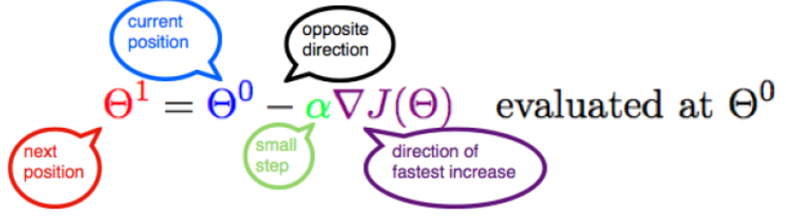

…

## [Machine Learning Mastery - How to Configure the Number of Layers and Nodes in a Neural Network](https://machinelearningmastery.com/how-to-configure-the-number-of-layers-and-nodes-in-a-neural-network/)

## [Medium – Batch normalization in Neural Networks](https://towardsdatascience.com/batch-normalization-in-neural-networks-1ac91516821c)

## [Medium – Why do we subtract the slope * a in Gradient Descent?](https://medium.com/@aerinykim/why-do-we-subtract-the-slope-a-in-gradient-descent-73c7368644fa)

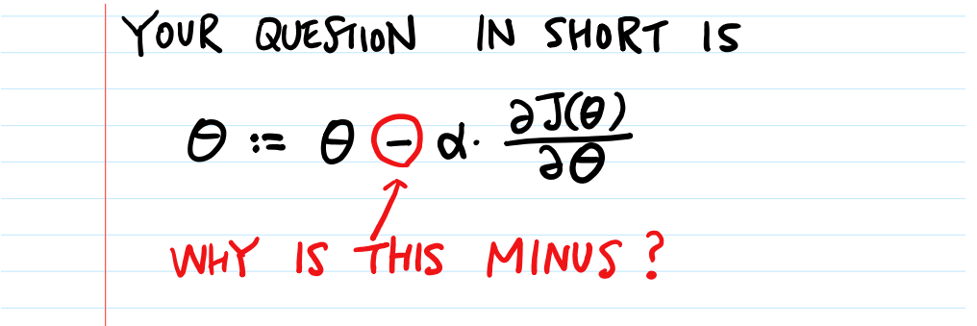 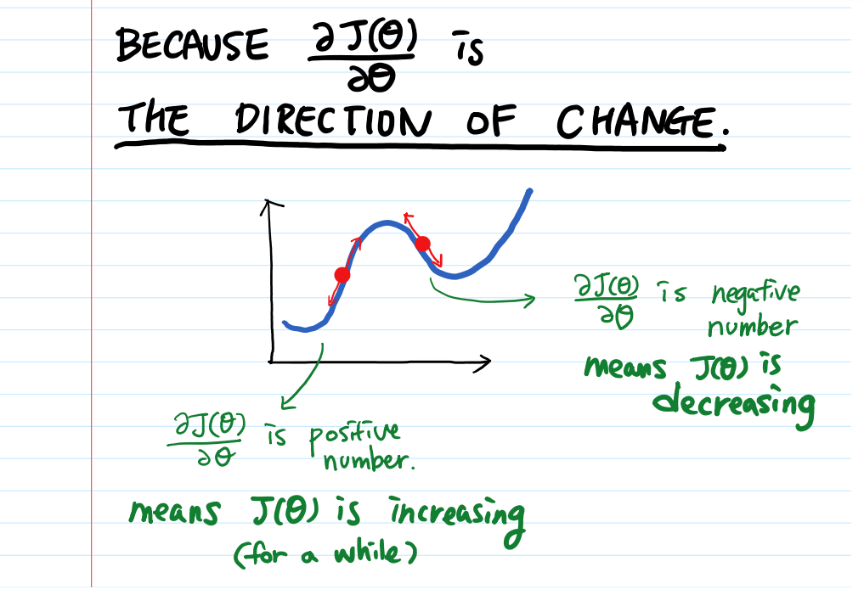

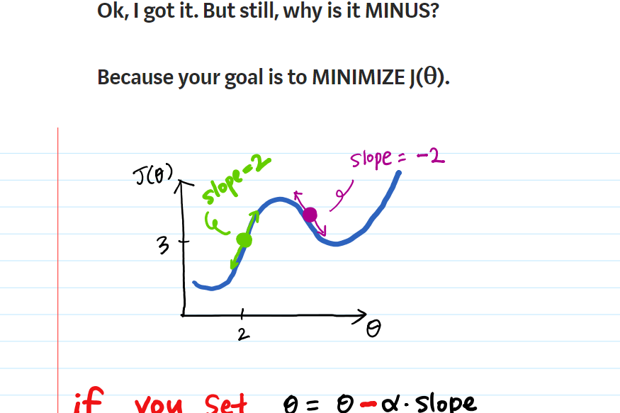 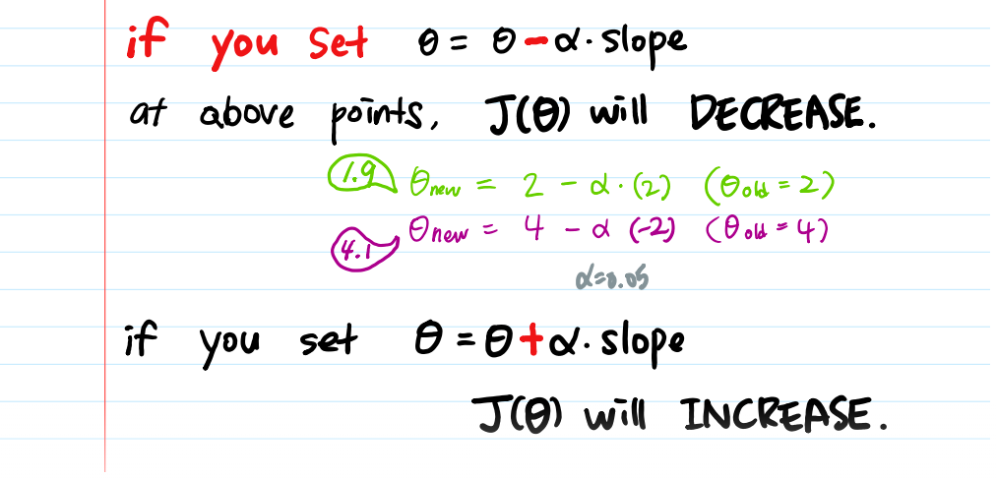

So if the slope is positive – J is increasing, then we try to decrease it – making it close to another minima. The same goes for if the slope is negative.

## [Quora - What is the implication of the Universal Approximation Theorem over deep learning methodology?](https://www.quora.com/What-is-the-implication-of-the-Universal-Approximation-Theorem-over-deep-learning-methodology)

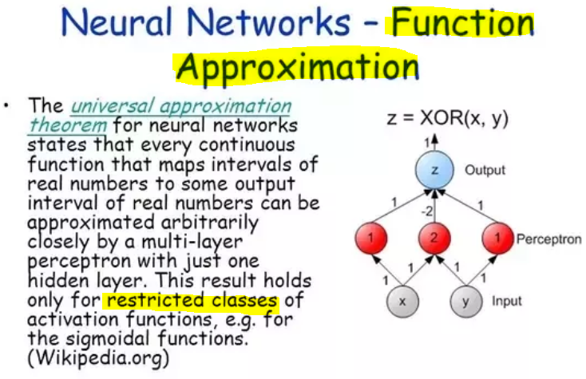

## [ResearchGate - What is the minimum sample size required to train a Deep Learning model - CNN?](https://www.researchgate.net/post/What_is_the_minimum_sample_size_required_to_train_a_Deep_Learning_model-CNN)

**Jack Kelly**

It really is pretty hard (if not impossible) to give a 'one size fits all' answer.  The amount of training data you require is dependent on many different aspects of your experiment:

* how different are the classes that you're trying to separate?  e.g. if you were just trying to classify black versus white images then you'd need very few training examples!  But if you're trying to solve ImageNet then you need training data on the order of 1000 examples per class.
* how aggressively can you augment the training data?  (Sander Dieleman's blog post on 'Classifying plankton with deep neural networks' gives a great introduction to data augmentation; and he talks a little about the question of 'how much data do deep neural nets require')
* can you use pre-trained weights to initialise the lower layers of your net? (e.g. using weights trained from ImageNet)
* do you plan to use batch normalisation? It can help reduce the amount of data required.
* There are loads of other 'tricks' discussed in the literature on ways to squeeze maximum advantage from a small training dataset.

[http://benanne.github.io/2015/03/17/plankton.html](https://www.researchgate.net/deref/http%3A%2F%2Fbenanne.github.io%2F2015%2F03%2F17%2Fplankton.html)

…

# Feedforward

## [Hackernoon – Deep Learning: Feedforward Neural Networks Explained](https://hackernoon.com/deep-learning-feedforward-neural-networks-explained-c34ae3f084f1)

…

From my previous post on [Universal Approximation theorem](https://hackernoon.com/illustrative-proof-of-universal-approximation-theorem-5845c02822f6), we have proved that even though single sigmoid neuron can’t deal with non-linear data. If we connect multiple sigmoid neurons in an effective way, we can approximate the combination of neurons to any complex relationship between input and the output, required to deal with non-linear data.

**Simple Deep Neural Network**

Example of a complex decision boundary as shown below:

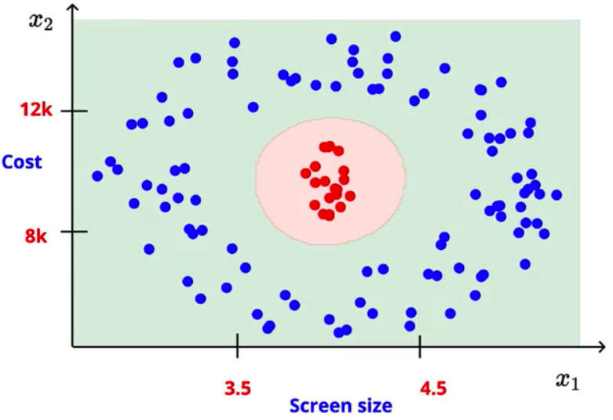

We know that by using a single sigmoid neuron, it is impossible to obtain this kind of non-linear decision boundary. Regardless of how we vary the sigmoid neuron parameters **w** and **b**. Now change the situation and use a simple network of neurons for the same problem and see how it handles.

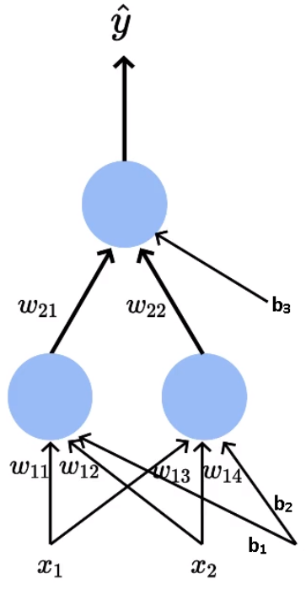

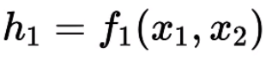

If we apply the sigmoid function:

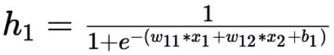

Similarly

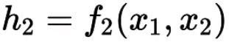

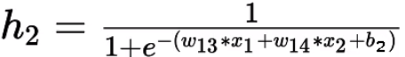

The output

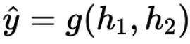

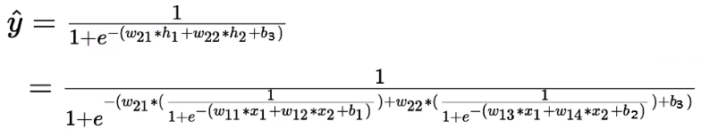

Earlier we can adjust only w₁, w₂ and b — parameters of a single sigmoid neuron. Now we can adjust the 9 parameters (w₁₁, w₁₂, w₁₃, w₁₄, w₂₁, w₂₂, b₁, b₂, b₃), which allows the handling of much complex decision boundary. By trying out the different configurations for these parameters we would be able to find the optimal surface where output for the entire middle area (red points) is one and everywhere else is zero, what we desire.

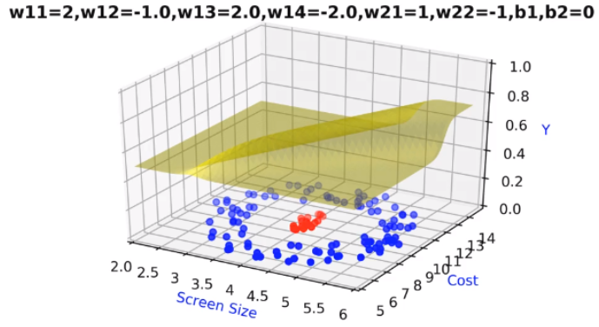

**Generic Deep Neural Network**

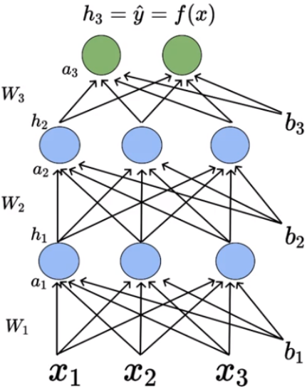

For each of these neurons:

* 1. Pre-activation represented by ‘a’: It is a weighted sum of inputs plus the bias.
  2. Activation represented by ‘h’: Activation function is Sigmoid function.
* W(Layer number)(Neuron number in the layer)(Input number)
* b(Layer number)(Bias number associated for that input)
* W₁₁₁— Weight associated with the first neuron present in the first hidden layer connected to the first input.
* W₁₁₂— Weight associated with the first neuron present in the first hidden layer connected to the second input.
* b₁₁ — Bias associated with the first neuron present in the first hidden layer.
* b₁₂ — Bias associated with the second neuron present in the first hidden layer.

…

The pre-activation at each layer is the weighted sum of the inputs from the previous layer plus bias. The mathematical equation for pre-activation at each layer ‘i’ is given by,

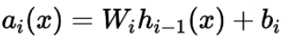

The activation at each layer is equal to applying the sigmoid function to the output of pre-activation of that layer. The mathematical equation for the activation at each layer ‘i’ is given by,

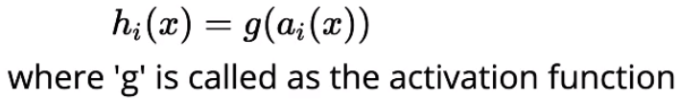

Finally, we can get the predicted output of the neural network by applying some kind of activation function (could be softmax depending on the task) to the pre-activation output of the previous layer.



**Computations in Deep Neural Network**

Consider that you have 100 inputs and 10 neurons in the first and second hidden layers.

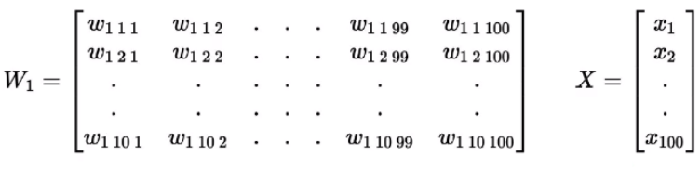

Now let’s see how we can compute the pre-activation for the first neuron of the first layer a₁₁. We know that pre-activation is nothing but the weighted sum of inputs plus bias. In other words, it is the dot product between the first row of the weight matrix W₁ and the input matrix X plus bias b₁₁.



Similarly the pre-activation for other 9 neurons in the first layer given by,

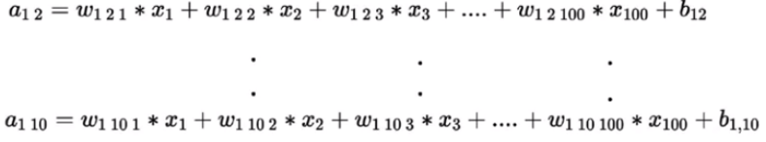

In short, the overall pre-activation of the first layer is given by,

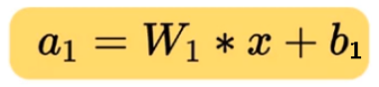

Where,

W₁ is a matrix containing the individual weights associated with the corresponding inputs and b₁ is a vector containing(b₁₁, b₁₂, b₁₃,….,b₁₀) the individual bias associated with the sigmoid neurons.

The activation for the first layer is given by,

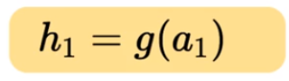

Where ‘g’ represents the sigmoid function.

Remember that a₁ is a vector of 10 pre-activation values, here we are applying the element-wise sigmoid function on all these 10 values and storing them in another vector represented as h₁. Similarly, we can compute the pre-activation and activation values for ’n’ number of hidden layers present in the network.

**Output Layer of DNN**

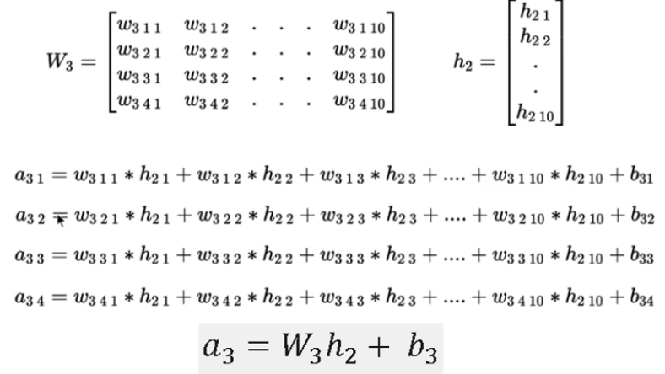

The output Activation function is chosen depending on the task at hand, can be softmax or linear.

To find out the predicted output from the network, we are applying some function (which we don’t know yet) to the pre-activation values.

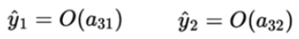

**Softmax Function**

We will use the Softmax function as the output activation function. The most frequently used activation function in deep learning for classification problems.

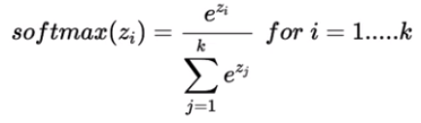

In the Softmax function, the output is always positive, irrespective of the input.

**Loss Function**

…

Cross-entropy loss for binary classification is given by,

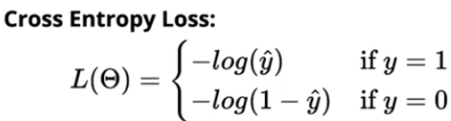

Cross-entropy loss for multi-class classification is given by,

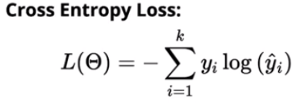

**Learning Algorithm: Non-Mathy Version**

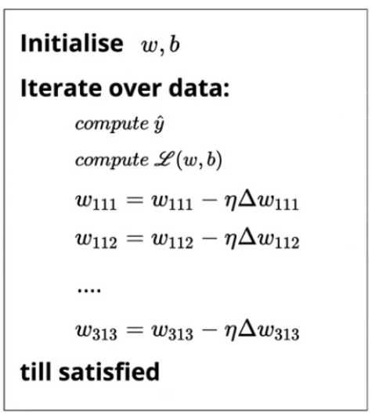

## [Briliant – Feedforward Neural Networks](https://brilliant.org/wiki/feedforward-neural-networks/)

Feedfoward neural networks are primarily used for [supervised learning](https://brilliant.org/wiki/supervised-learning/) in cases where the data to be learned is neither sequential nor time-dependent.

**Singe-layer Perceptron**

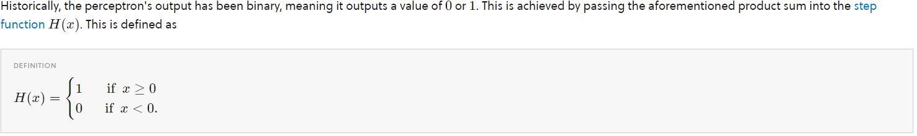

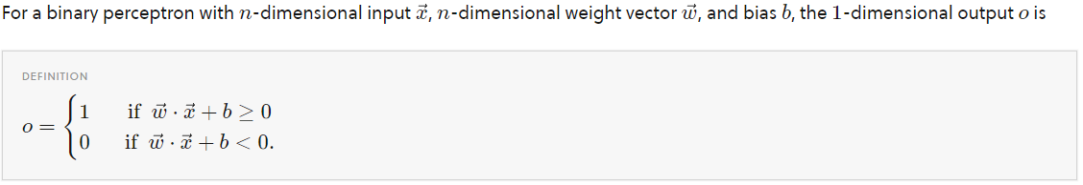

**Limitations**

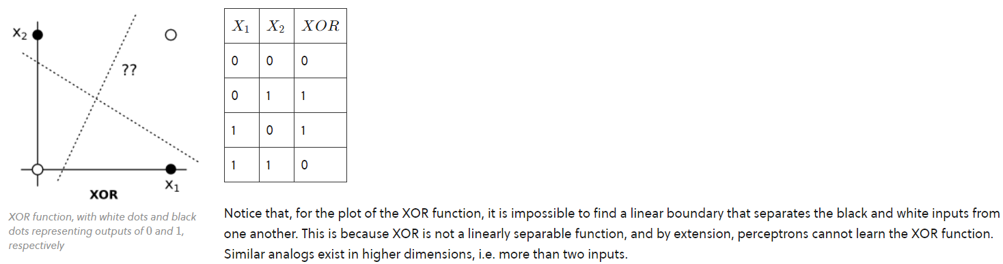

**Error Function**

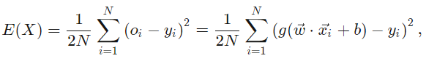

**Multi-layer Perceptron**

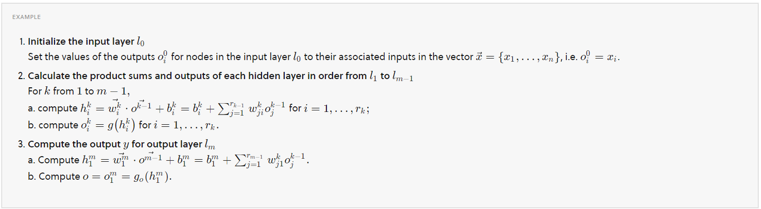

## [Stack Abuse – TensorFlow Neural Network Tutorial](https://stackabuse.com/tensorflow-neural-network-tutorial/)

Since neural networks, but also other ML algorithms, mostly work with matrix multiplications, it is much quicker to run them on Graphical Processing Units (GPUs), rather than on standard Central Processing Units (CPUs).

TensorFlow supports both CPUs and GPUs, and Google has even produced its own specialized hardware for computing in the cloud, called [Tensor Processing Unit (TPU)](https://cloud.google.com/tpu/), which produces the [best performance](https://cloud.google.com/blog/big-data/2017/05/an-in-depth-look-at-googles-first-tensor-processing-unit-tpu) among the different processing units.

**Installation**

… (Show how to install. Great!)

**Core API components**

*Tensors*

*Tensors* are the basic data structure in TensorFlow which store data in any number of dimensions, similar to multi dimensional arrays in NumPy. There are three basic types of tensors: constants, variables, and placeholders.

* *Constants* are immutable type of tensors. They could be seen as nodes without inputs, outputting a single value they store internally.
* *Variables* are mutable type of tenosrs whose value can change during a run of a graph. In ML applications, the variables usually store the parameters which need to be optimized (eg. the weights between nodes in a neural network). Variables need to be initialized before running the graph by explicitly calling a special operation.
* *Placeholders* are tensors which store data from external sources. They represent a "promise" that a value will be provided when the graph is run. In ML applications, placeholders are usually used for inputing data to the learning model.

*Graphs*

*Sessions*

Finally, our graph should be run inside a session.

**A neural network model**

…

# Back-propagation

Ok, in short, what the hell is back propagation with SGD?

Remember that, when you learn S Gradient Descent in basic ML course abour linear regression, you use this formula to change weight in order to achieve smaller error

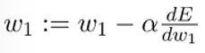

Okay, here, you can easily calculate $dE/d_{w1}$ (the LINK between ERROR and WEIGHT 1) since you have a very simple linear regression equation (e.g. $y=θ_{0}+θ_{1}x$) and you can easily calculate various things in $dE/d_{w1}$.

But now you have a network like this:

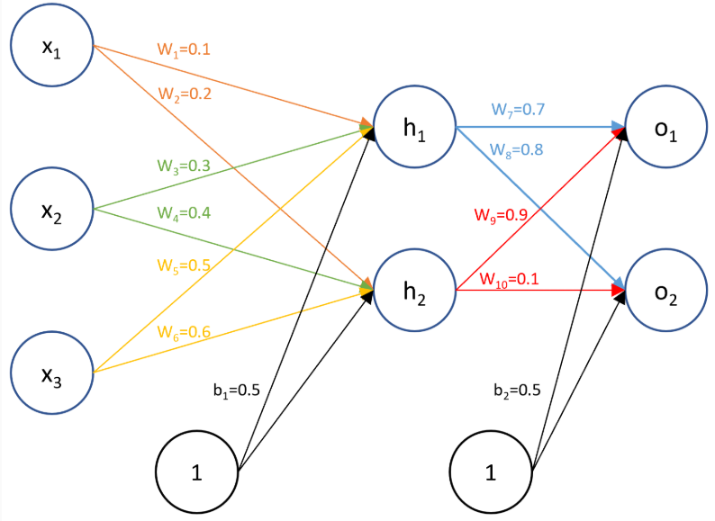

How can you even LINK the ERROR with WEIGHT 1, or calculate $dE/d_{w1}$ (For what??? In order to use SGD, my dear)? You don’t have a simple equation any more. The answer: to LINK them, use back propagation.

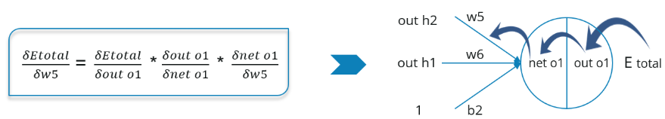

## [Backpropagation Example With Numbers Step by Step](https://www.anotsorandomwalk.com/backpropagation-example-with-numbers-step-by-step/)

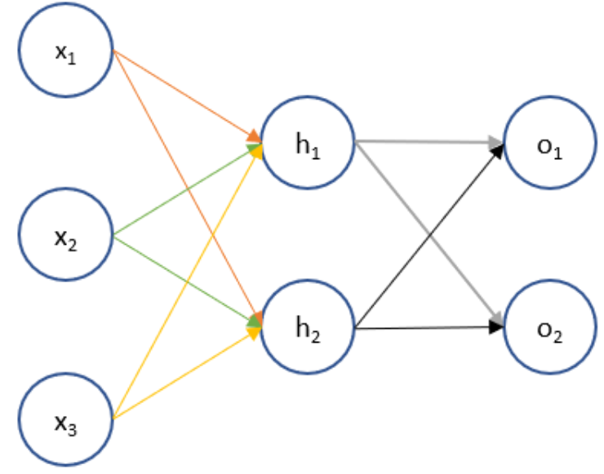

(1) Initialize weights for the parameters we want to train

(2) Forward propagate through the network to get the output values

(3) Define the error or cost function and its first derivatives

(4) Backpropagate through the network to determine the error derivatives

(5) Update the parameter estimates using the error derivative and the current value

**Step 1**





**Step 2**

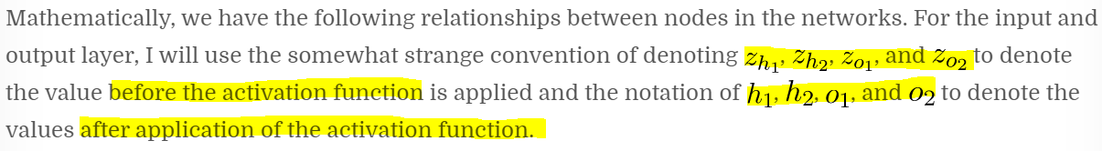

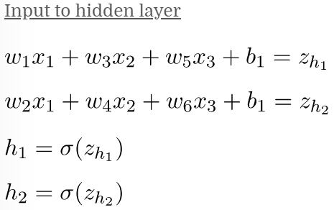 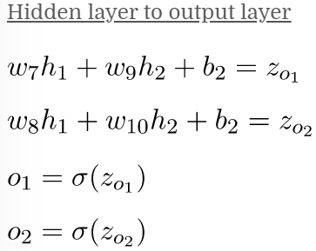

We can use the formulas above to forward propagate through the network. I’ve shown up to four decimal places below but maintained all decimals in actual calculations.

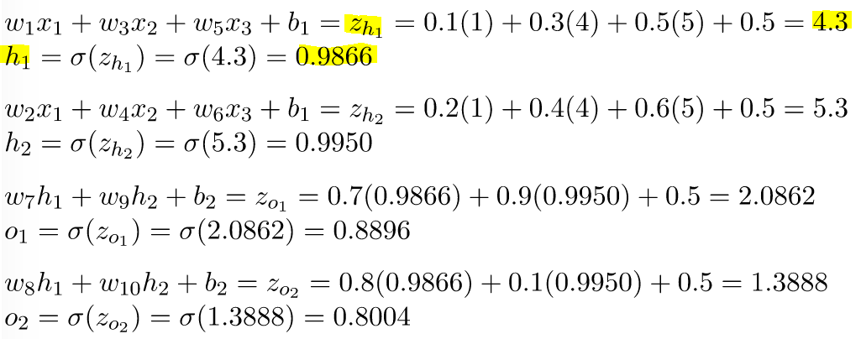

(use Sigmog)

**Step 3**

We now define the sum of squares error using the target values and the results from the last layer from forward propagation.

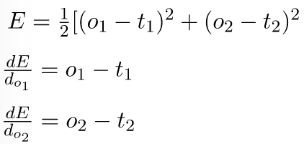

**Step 4**

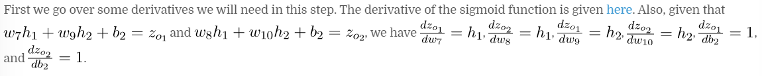



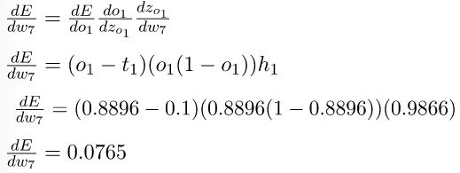

… (calculate )

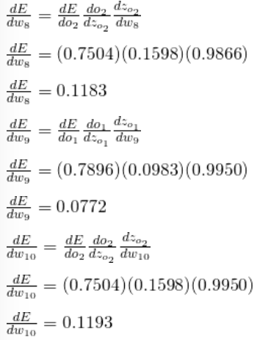

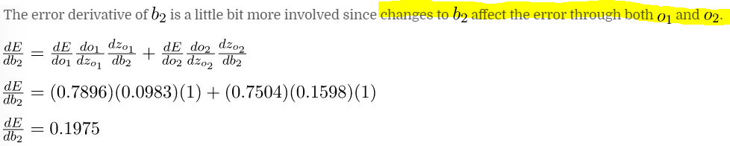

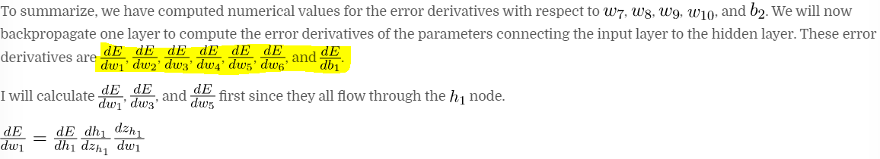

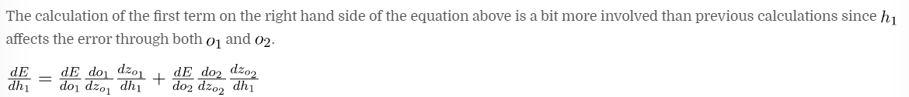

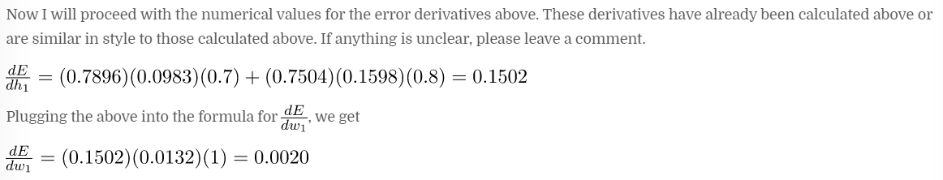

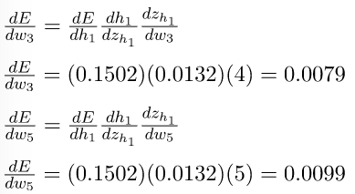

…

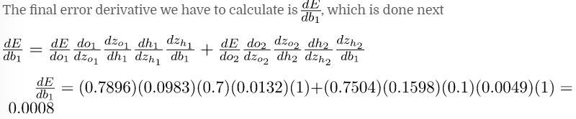

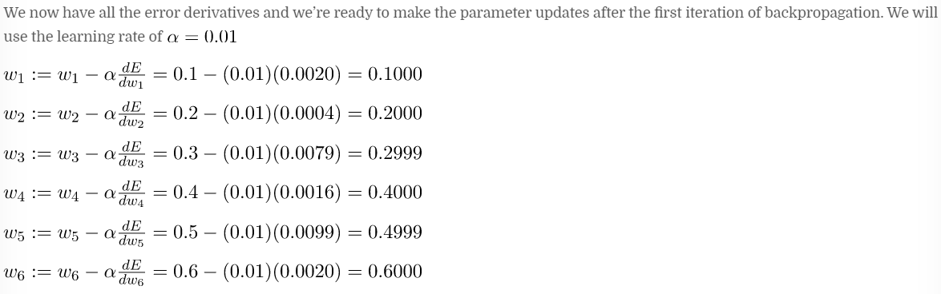

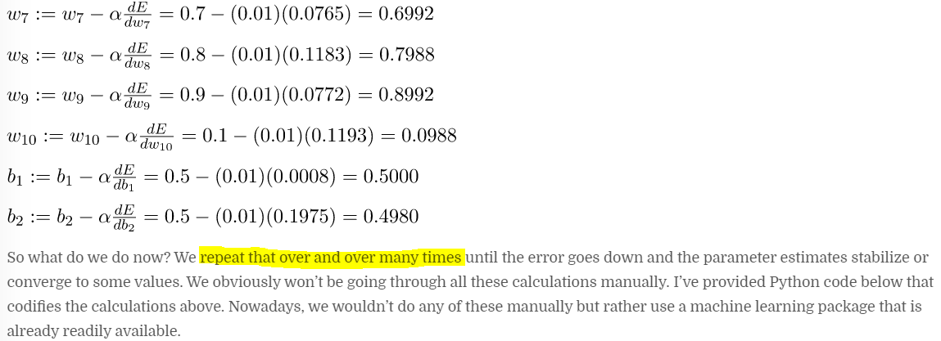

## [Edureka! – Backpropagation – Algorithm For Training A Neural Network](https://www.edureka.co/blog/backpropagation/)

…

Below are the steps involved in Backpropagation:

* Step – 1: Forward Propagation
* Step – 2: Backward Propagation
* Step – 3: Putting all the values together and calculating the updated weight value

…



…

## [Stackoverflow – What is the difference between SGD and back-propagation?](https://stackoverflow.com/questions/37953585/what-is-the-difference-between-sgd-and-back-propagation)

Backpropagation is an efficient method of **computing gradients** in directed graphs of computations, such as neural networks. This is **not** a learning method, but rather a nice computational trick which is **often used in learning methods**. This is a simple implementation of **chain rule** of derivatives, which simply gives you the ability to compute all required partial derivatives in linear time in terms of the graph size (while naive gradient computations would scale exponentially with depth).

SGD is one of many optimization methods, namely **first order optimizer**, meaning, that it is based on analysis of the **gradient** of the objective. Consequently, in terms of neural networks it is often applied together with backprop to make efficient updates. You could also apply SGD to gradients obtained in a different way (from sampling, numerical approximators etc.). Symmetrically you can use other optimization techniques with backprop as well, everything that can use gradient/jacobian.

This common misconception comes from the fact, that for simplicity people sometimes say "trained with backprop", what actually means (if they do not specify optimizer) "trained with SGD using backprop as a gradient computing technique". Also, in old textbooks you can find things like "delta rule" and other a bit confusing terms, which describe exactly the same thing (as neural network community was for a long time a bit independent from general optimization community).

Thus you have two layers of abstraction:

* gradient computation - where backprop comes to play
* optimization level - where techniques like SGD, Adam, Rprop, BFGS etc. come into play, which (if they are first order or higher) use gradient computed above

…

**Stochastic gradient descent** (SGD) is an optimization method used e.g. to minimize a loss function.

In the SGD, you use *1 example*, at each iteration, to update the weights of your model, depending on the error due to this example, instead of using the average of the errors of *all* examples (as in "simple" *gradient descent*), at each iteration. To do so, SGD needs to compute the "gradient of your model".

**Backpropagation** is an efficient technique to compute this "gradient" that SGD uses.

# Recurrent Neural Networks (Can write blog)

Khác với FF network, khi người dùng input từ (và machine sẽ đó), người dùng chỉ INPUT MỘT TỪ và machine phải bắt đầu đoán từ khoảng khắc đó, ko phải đợi cho đến khi từ thứ ba, thứ 4 đánh ra thì mới bắt đầu đoán.

Tóm lại: mỗi lần nhập 1 input, phải đoán dựa vào những input đã nhập.

**Consider: The user wants to type “Hello”**

Input less than 6 words, one word at a time

Non-recurrent:

* Fixed number of input (so it forces user to type EXACTLY 4 or 5 to get recommended “Hello”)
* The **ORDER** of input doesn’t matter !!! (Remember the Non-recurrent models, do they care about order of input? NONE!)
* All inputs need to be availabel at same time to get the output ! (Impossible, since we are typing one at a time)

Recurrent:

* Scalable number of input (May recommend “Hello” after 3 or 4 word typed?)
* **ORDER** of input matters.
* No need to have all input at the same time to get the output.

## [Wiki - Recurrent neural network](https://en.wikipedia.org/wiki/Recurrent_neural_network)

This is also called FEEDBACK NEURAL NETWORK.

Two broad classes of networks with a similar general structure, where:

* One is [finite impulse](https://en.wikipedia.org/wiki/Finite_impulse_response)
* The other is [infinite impulse](https://en.wikipedia.org/wiki/Infinite_impulse_response).

A finite impulse recurrent network is a [directed acyclic graph](https://en.wikipedia.org/wiki/Directed_acyclic_graph) that can be unrolled and replaced with a strictly feedforward neural network, while an infinite impulse recurrent network is a [directed cyclic graph](https://en.wikipedia.org/wiki/Directed_cyclic_graph) that can not be unrolled.

**Neural history compressor**

The neural history compressor is an unsupervised stack of RNNs….

A [generative model](https://en.wikipedia.org/wiki/Generative_model) partially overcame the [vanishing gradient problem](https://en.wikipedia.org/wiki/Vanishing_gradient_problem)[[35]](https://en.wikipedia.org/wiki/Recurrent_neural_network#cite_note-hochreiter1991-35) of [automatic differentiation](https://en.wikipedia.org/wiki/Automatic_differentiation) or [backpropagation](https://en.wikipedia.org/wiki/Backpropagation) in neural networks in 1992. In 1993, such a system solved a "Very Deep Learning" task that required more than 1000 subsequent layers in an RNN unfolded in time

## [MLM - A Gentle Introduction to RNN Unrolling](https://machinelearningmastery.com/rnn-unrolling/)

**Unrolling the Forward Pass**

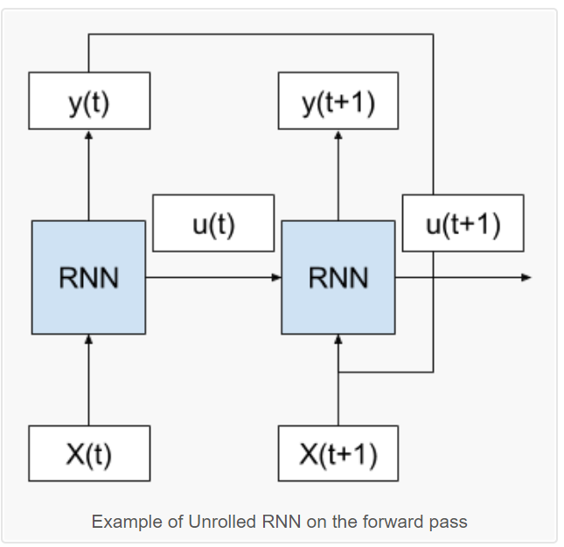

We can see that the cycle is removed and that the output (y(t)) and internal state (u(t)) from the previous time step are passed on to the network as inputs for processing the next time step.

Key in this conceptualization is that the network (RNN) does not change between the unfolded time steps. Specifically, the same weights are used for each time step and it is only the outputs and the internal states that differ.

In this way, it is as though the whole network (topology and weights) are copied for each time step in the input sequence.

Further, each copy of the network may be thought of as an additional layer of the same feed forward neural network.

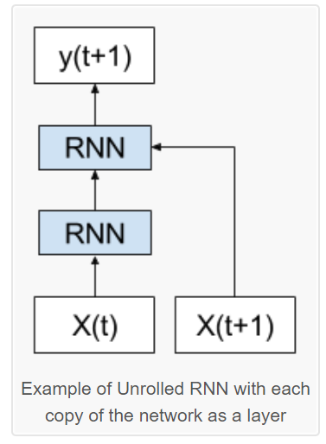

*“RNNs, once unfolded in time, can be seen as very deep feedforward networks in which all the layers share the same weights.”*

## [bouvet - Explaining Recurrent Neural Networks](https://www.bouvet.no/bouvet-deler/explaining-recurrent-neural-networks)

**Limitations with RNNs**

The "working memory" of standard RNNs struggles to retain longer term dependancies. The below image illustrates this problem:

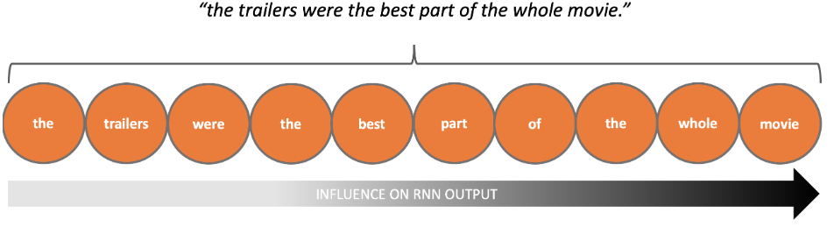

*The "working memory" of RNNs can "forget" information from early in a sequence*

This behaviour is due to the *Vanishing Gradient* problem, and can cause problems when early parts of the input sequence contain important contextual information.

**Solving the Vanishing Gradient Problem with LSTM Networks**

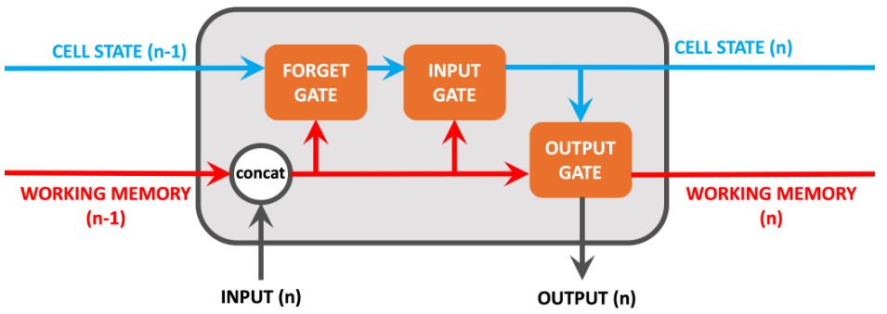

## [GeekforGeeks – Introduction to Recurrent Neural Network](https://www.geeksforgeeks.org/introduction-to-recurrent-neural-network/)

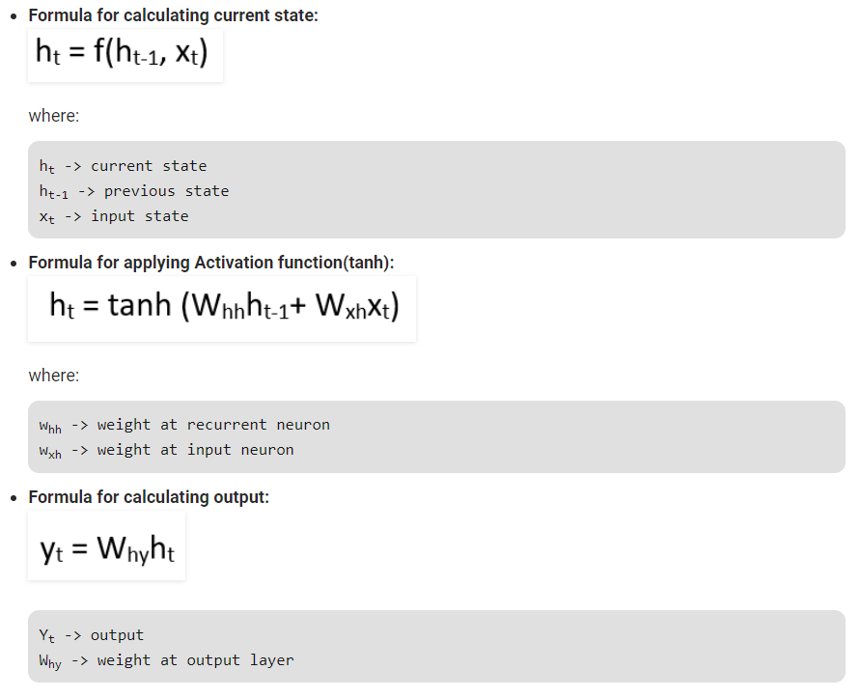

[**Medium - Recurrent Neural Networks and LSTM explained**](https://medium.com/@purnasaigudikandula/recurrent-neural-networks-and-lstm-explained-7f51c7f6bbb9)

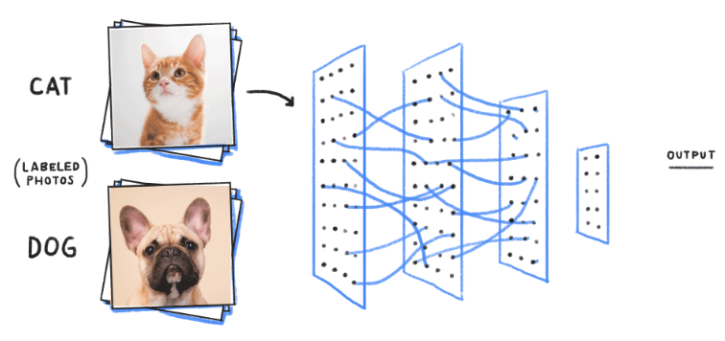

In this training process, the first picture that the Neural network exposed to, will not necessarly alter how it classifies the Second one.

here the output of Cat does not relate to the output Dog. There are several scenario’s where the previous understanding of data is important.for example: Reading book, understanding lyrics,..,. These networks do not have memory in order to understand Sequential data like Reading books.

**Backpropogate Through Time:**

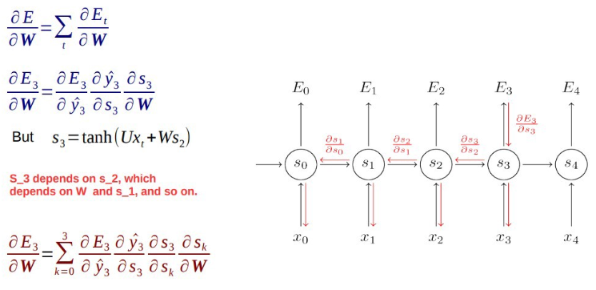

While Backpropogating you may get 2 types of issues.

* **Vanishing Gradient**
* **Exploding Gradient**

**Vanishing Gradient**

*where the contribution from the earlier steps becomes insignificant in the gradient descent step.*

what if the partial derivation of error with respect to weight is very less than 1?

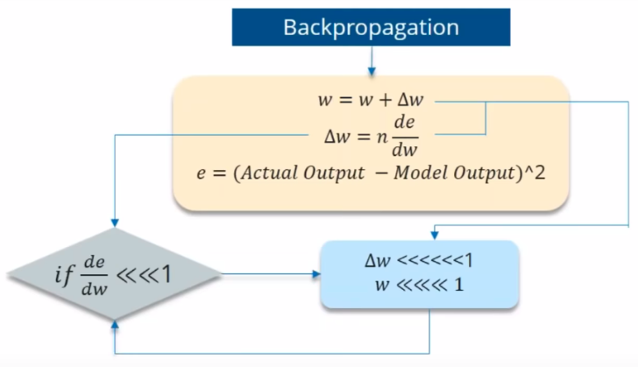

If the partial derivation of Error is less than 1, then when it get multiplied with the Learning rate which is also very less. then Multiplying learning rate with partial derivation of Error wont be a big change when compared with previous iteration.

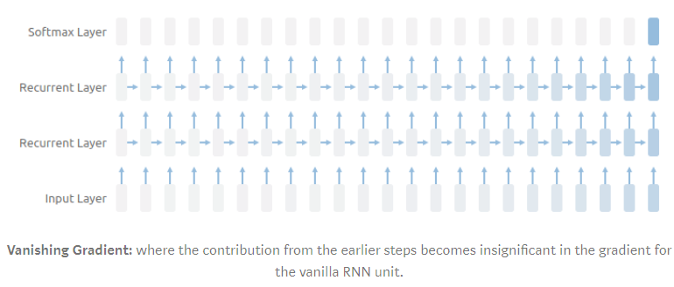

**Exploding Gradient**

We speak of Exploding Gradients when the algorithm assigns a stupidly high importance to the weights, without much reason. But fortunately, this problem can be easily solved if you truncate or squash the gradients.

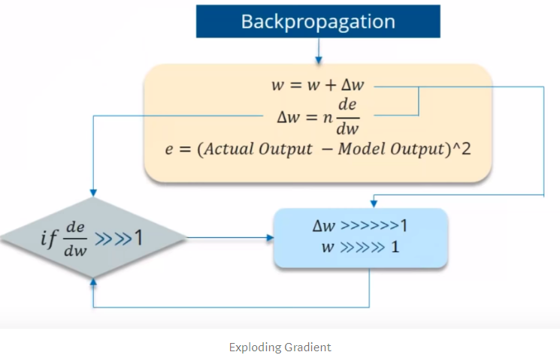

**How can you overcome the Challenges of Vanishing and Exploding Gradience?**

1. **Vanishing Gradience** can be overcome with

* Relu activation function.
* LSTM, GRU.

2. **Exploding Gradience** can be overcome with

* Truncated BTT(instead starting backprop at the last time stamp, we can choose similar time stamp, which is just before it.)
* Clip Gradience to threshold.
* RMSprop to adjust learning rate.

## [Hackernoon – RNN or Recurrent Neural Network for Noobs](https://hackernoon.com/rnn-or-recurrent-neural-network-for-noobs-a9afbb00e860)

We have vanilla networks like Convolutional ones which perform very well. Why do we need another type of a network? In order to explain RNNs you need to first understand something called a sequence. Let's talk about **sequences**first.

Sequence is a stream of data (finite or infinite) which are interdependent. Examples would be time series data, informative pieces of strings, conversations etc.

* In a conversation a sentence means something but the entire flow of the conversation mostly means something completely different.
* Also in a time series data like stock market data, a single tick data means the current price, but a full days data will show movement and allow us to take decision whether to buy or sell.

(Remember the methods that you learnt before, all of them generally only take input at a certain time to generate output, right? But here, recurrent network take inputs in various time!)

CNNs generally don’t perform well when the input data is interdependent in a sequential pattern. CNNs don’t have any sort of correlation between previous input to the next input. So all the outputs are self dependent. CNN takes in an input and outputs based on the trained model. If you run 100 different inputs none of them would be biased by the previous output (or “not related).

But imagine a scenario like sentence generation or text translation. All the words generated are dependent on the words generated before (inputs depent on each other) (in certain cases, it’s dependent on words coming after as well). So you need to have some bias based on your previous output. This is where RNNs shine. RNNs have in them a sense some memory about what happened earlier in the sequence of data. This helps the system to gain context.

Theoretically RNNs have infinite memory, meaning they have the capability to look back indefinitely. By look back I mean all previous inputs. But practically they can only look back a last few steps.

(OKAY ! SO TRADITIONAL MODEL DON’T CARE WTF THEY GENERATED (OUTPUT) BUT NOW, RECURRENT NEED TO KNOW WHAT THEY GENERATED (OUTPUT) AS WELL TO MAKE DECISION?)

**1. Language Modelling and Generating Text**

Given a sequence of word, here we try to predict the likelihood of the next word.

…

**Feed-forward Networks Primer**

One important thing to note here. In a feed-forward network whatever image is shown to the classifier during test phase, it doesn’t alter the weights so the second decision is not affected. This is one very important difference between feed-forward networks and recurrent nets.

*Feed-forward nets don’t remember historic input data at test time unlike recurrent networks.*

It’s always point in time decision. They only remember things that were shown to them during the training phase.

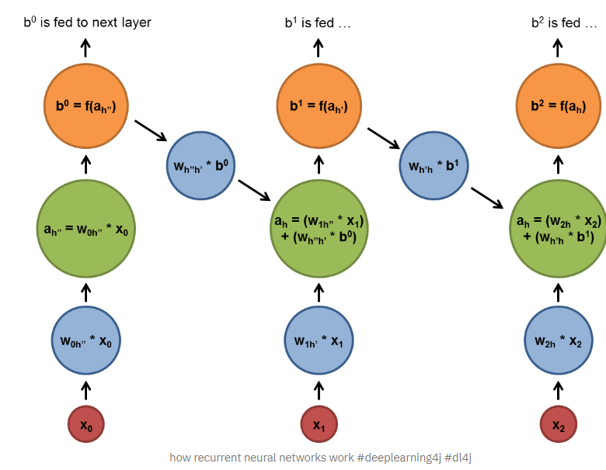

**Recurrent Neuron**

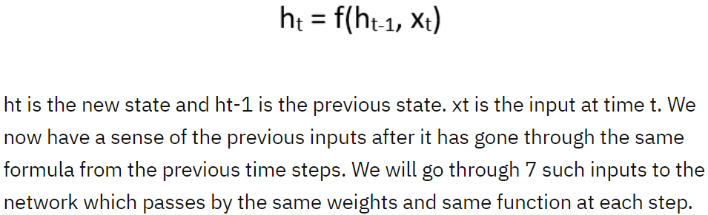

…

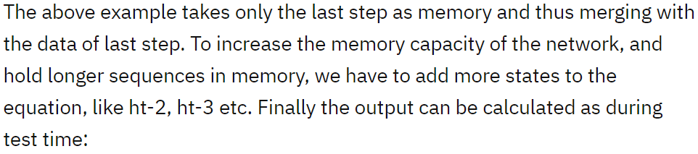

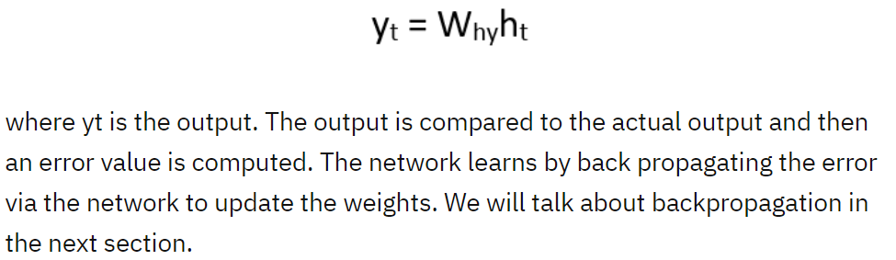

**Backpropagation Through Time (BPTT)**

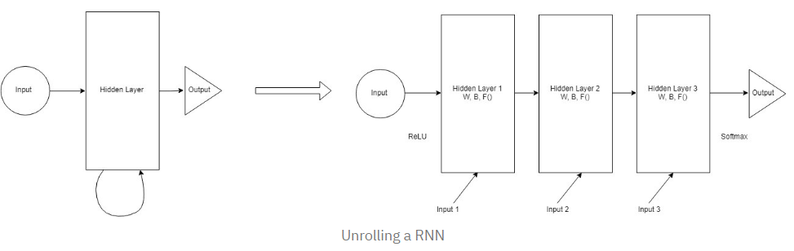

## [Quora - How does a recurrent neural network work for non-sequential data?](https://www.quora.com/How-does-a-recurrent-neural-network-work-for-non-sequential-data)

In this picture, the input, xtxt, is the input at time tt. As in the feed-forward case, we feed the input into our neuron (block A), it does some computation, and we get the output htht. However note an additional recurrent connection feeding the same output htht back into A (the connection is drawn leaving block A on the right size, and entering on the left). **Note this recurrent connection will be used as part of the input computation at the next time step.** (retain information of previous step).

## [Suriyadeepan Ram – Unfolding RNNs](http://complx.me/2017-01-07-unfolding-rnn/)

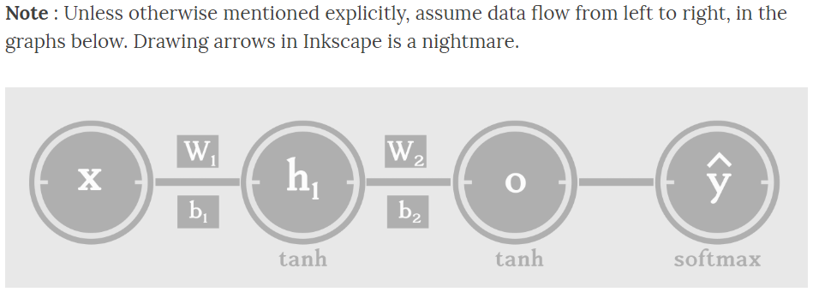

…

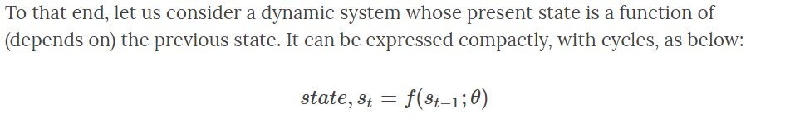

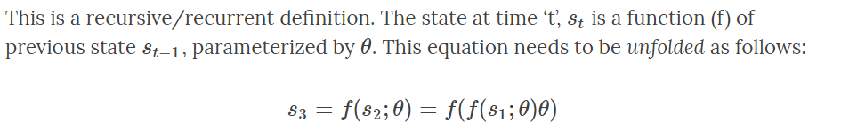

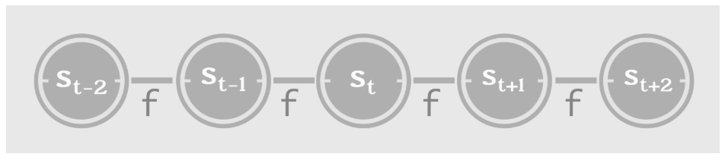

## [TDS – Vanishing Gradients in Recurrent Neural Networks](https://medium.com/mlrecipies/vanishing-gradients-in-recurrent-neural-networks-b231c2afde4)

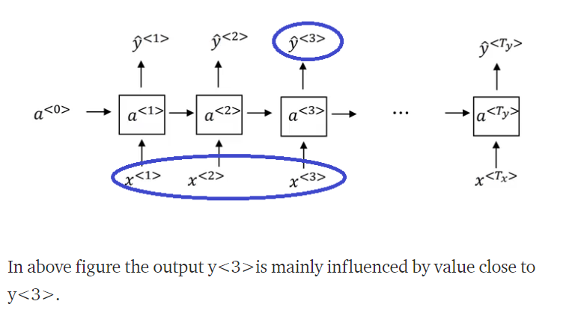 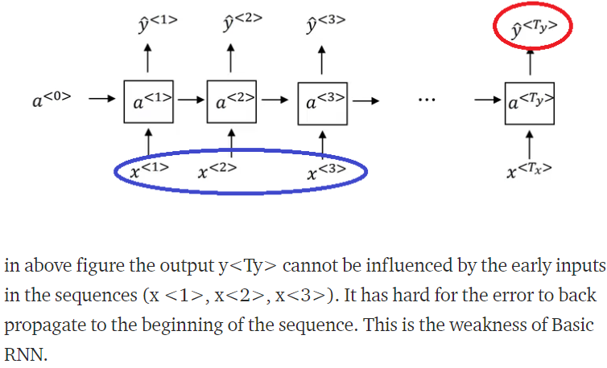

**How to Solve the Vanishing Gradients:**

GRU (gated recurrent units) or LSTMs(Long Short Term Memory), both are a very effective solution for addressing the vanishing gradient problem and will allow our neural network to capture much longer range dependencies.

# Long Short Term Memory Networks

## [GeeksforGeeks – Long Short Term Memory Networks Explanation](https://www.geeksforgeeks.org/long-short-term-memory-networks-explanation/)

To solve the problem of Vanishing and Exploding Gradients in a deep Recurrent Neural Network.

An LSTM recurrent unit tries to “remember” all the past knowledge that the network is seen so far and to “forget” irrelevant data. This is done by introducing different activation function layers called **“gates”.**

Each LSTM recurrent unit also maintains a vector called the **Internal Cell State** which conceptually describes the information that was chosen to be retained by the previous LSTM recurrent unit.

A Long Short Term Memory Network consists of four different gates for different purposes:

1. **Forget Gate(f):** It determines to what extent to forget the previous data.
2. **Input Gate(i):** It determines the extent of information to be written onto the Internal Cell State.
3. **Input Modulation Gate(g):** It is often considered as a sub-part of the input gate and many literatures on LSTM’s do not even mention it and assume it inside the Input gate. It is used to modulate the information that the Input gate will write onto the Internal State Cell by adding non-linearity to the information and making the information **Zero-mean**. This is done to reduce the learning time as Zero-mean input has faster convergence. Although this gate’s actions are less important than the others and is often treated as a finesse-providing concept, it is good practice to include this gate into the structure of the LSTM unit.
4. **Output Gate(o):** It determines what output(next Hidden State) to generate from the current Internal Cell State.

The basic work-flow of a Long Short Term Memory Network is similar to the work-flow of a Recurrent Neural Network with only difference being that the Internal Cell State is also passed forward along with the Hidden State.

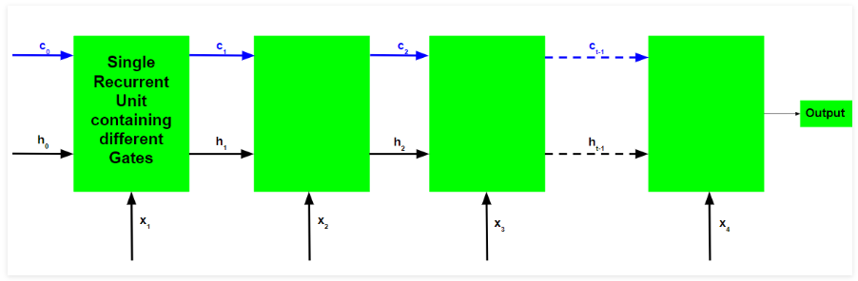

**Working of an LSTM recurrent unit:**

1. Take input:

* The current input,
* The previous hidden state
* The previous internal cell state.

1. Calculate the values of the four different gates by following the below steps:
   * For each gate, calculate the parameterized vectors for the current input and the previous hidden state by element-wise multiplication with the concerned vector with the respective weights for each gate.
   * Apply the respective activation function for each gate element-wise on the parameterized vectors. Below given is the list of the gates with the activation function to be applied for the gate.

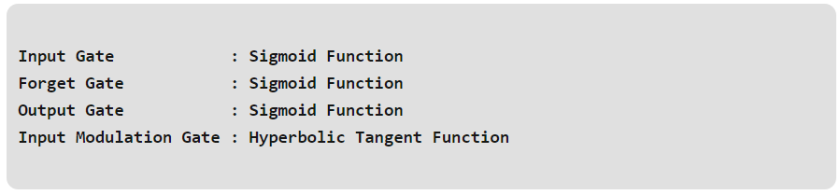

1. Calculate the current internal cell state by first calculating the element-wise multiplication vector of the input gate and the input modulation gate, then calculate the element-wise multiplication vector of the forget gate and the previous internal cell state and then adding the two vectors.

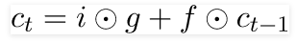

1. Calculate the current hidden state by first taking the element-wise hyperbolic tangent of the current internal cell state vector and then performing element wise multiplication with the output gate

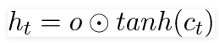

The above stated working is illustrated as below:

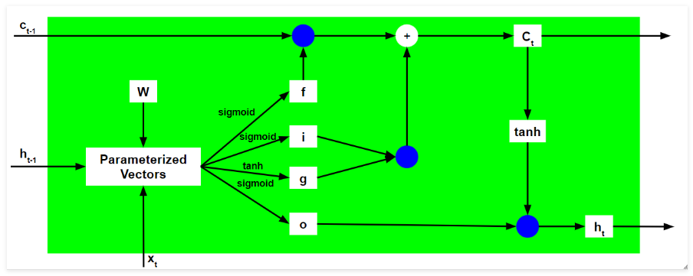

The blue circles denote element-wise multiplication. The weight matrix W contains different weights for the current input vector and the previous hidden state for each gate.

Just like Recurrent Neural Networks, an LSTM network also generates an output at each time step and this output is used to train the network using gradient descent.

…

**How does LSTM solve the problem of vanishing and exploding gradients?**

…

## [Colah’s blog - Understanding LSTM Networks](https://colah.github.io/posts/2015-08-Understanding-LSTMs/)

**LSTM Networks**

All recurrent neural networks have the form of a chain of repeating modules of neural network. In standard RNNs, this repeating module will have a very simple structure, such as a single tanh layer.

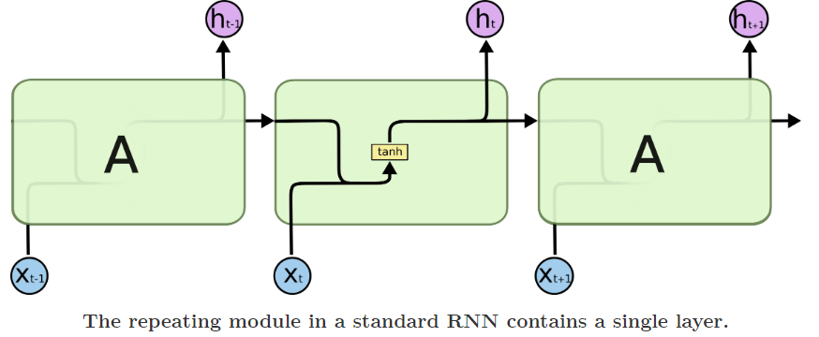

LSTMs also have this chain like structure, but the repeating module has a different structure. Instead of having a single neural network layer, there are four, interacting in a very special way.

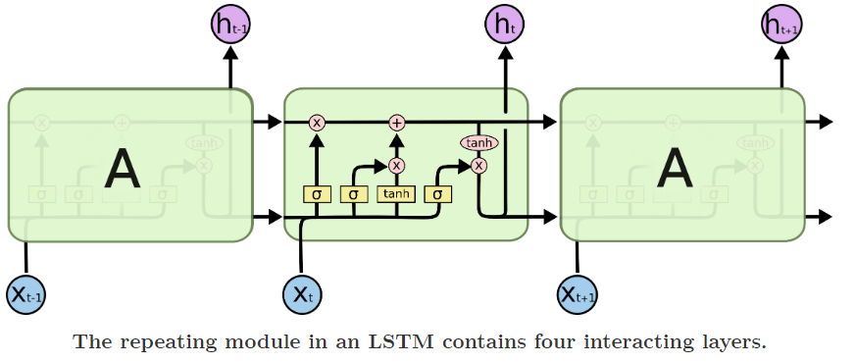

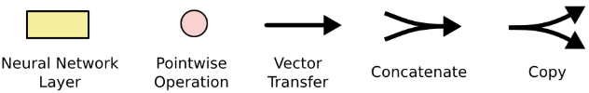

**The Core Idea Behind LSTMs**

The key to LSTMs is the cell state, the horizontal line running through the top of the diagram. It runs straight down the entire chain, with only some minor linear interactions. It’s very easy for information to just flow along it unchanged.

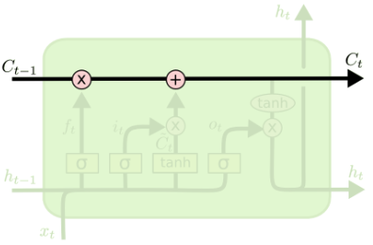

The LSTM does have the ability to remove or add information to the cell state, carefully regulated by structures called gates.

Gates are a way to optionally let information through. They are composed out of a sigmoid neural net layer and a pointwise multiplication operation.

The sigmoid layer outputs numbers between zero and one, describing how much of each component should be let through. A value of zero means “let nothing through,” while a value of one means “let everything through!”

An LSTM has three of these gates, to protect and control the cell state.

**Step-by-Step LSTM Walk Through**

*The first step*

in our LSTM is to decide what information we’re going to throw away from the cell state. This decision is made by a sigmoid layer called the “forget gate layer.” It looks at ht−1 and xt, and outputs a number between 0 and 1 FOR each number in the cell state Ct−1. A 1 represents “completely keep this” while a 0 represents “completely get rid of this.”

Let’s go back to our example of a language model trying to predict the next word based on all the previous ones. In such a problem, the cell state might include the gender of the present subject, so that the correct pronouns can be used. When we see a new subject, we want to forget the gender of the old subject.

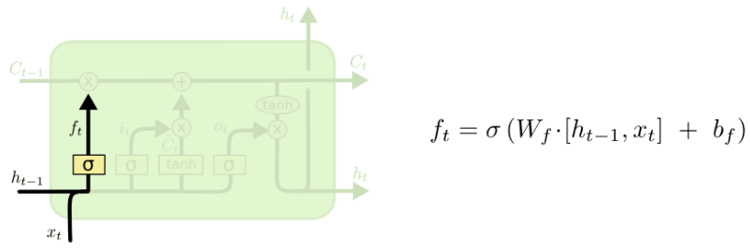

*The next step*

is to decide what new information we’re going to store in the cell state. This has two parts. First, a sigmoid layer called the “input gate layer” decides which values we’ll update. Next, a tanh layer creates a vector of new candidate values, C~t, that could be added to the state. In the next step, we’ll combine these two to create an update to the state.

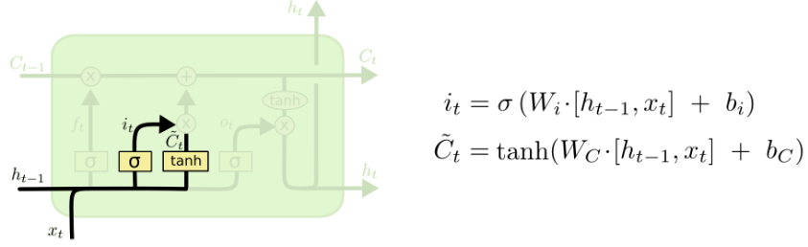

*It’s now time*

to update the old cell state, Ct−1 into the new cell state Ct. The previous steps already decided what to do, we just need to actually do it.

We multiply the old state by ft $→$ forgetting the things we decided to forget earlier (because this is multiple $→$ 0*x = 0 , 1*x = 1).

Then we add it∗C~t (same logic, 0*x = 0 , 1*x = 1 $→$ result vectors are chosen values ).This is the new candidate values, scaled by how much we decided to update each state value.

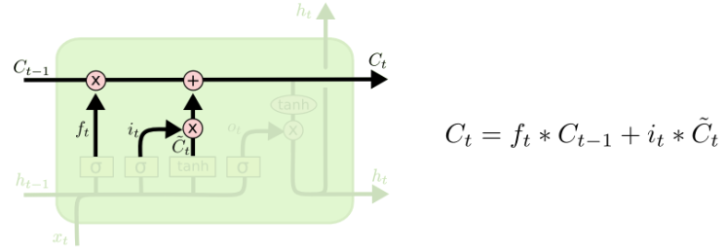

*Finally*

we need to decide what we’re going to output. This output will be based on our cell state, but will be a filtered version. First, we run a sigmoid layer which decides what parts of the cell state we’re going to output. Then, we put the cell state through tanh (to push the values to be between −1 and 1) and multiply it by the output of the sigmoid gate, so that we only output the parts we decided to.

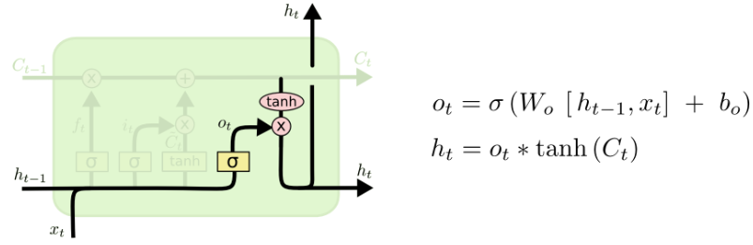

For the language model example, since it just saw a subject, it might want to output information relevant to a verb, in case that’s what is coming next. For example, it might output whether the subject is singular or plural, so that we know what form a verb should be conjugated into if that’s what follows next.

**Variants on Long Short Term Memory**

[**GeeksforGeeks – Deep Learning | Introduction to Long Short Term Memory**](https://www.geeksforgeeks.org/deep-learning-introduction-to-long-short-term-memory/)

LSTM has a chain structure that contains four neural networks and different memory blocks called **cells**.

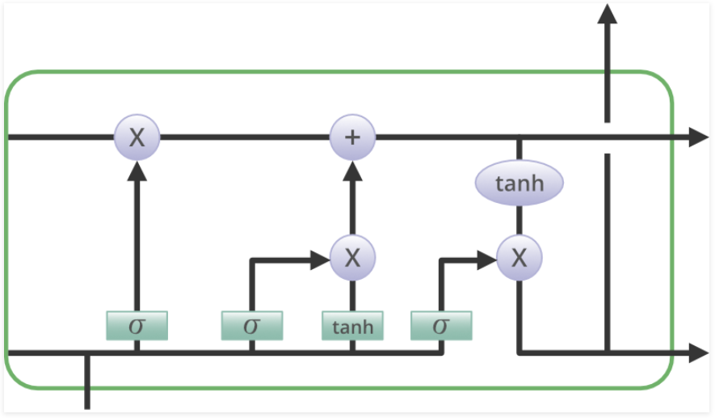

Information is retained by the cells and the memory manipulations are done by the**gates.** There are three gates –

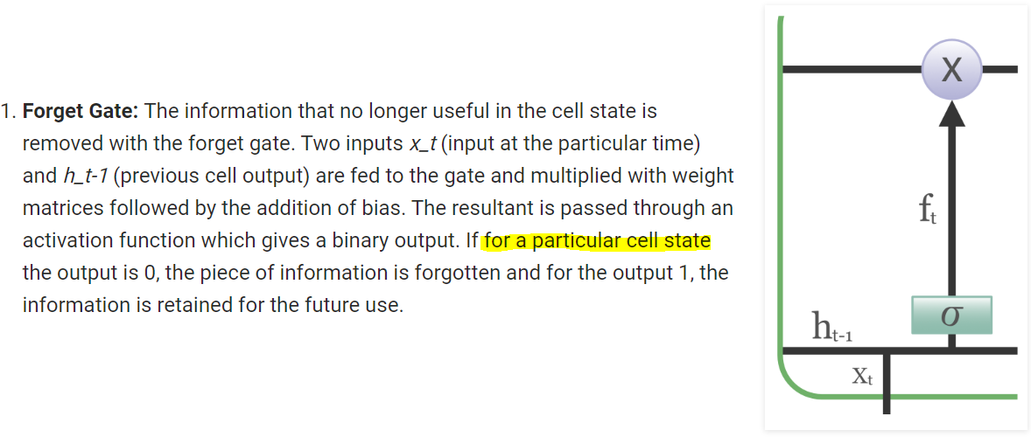

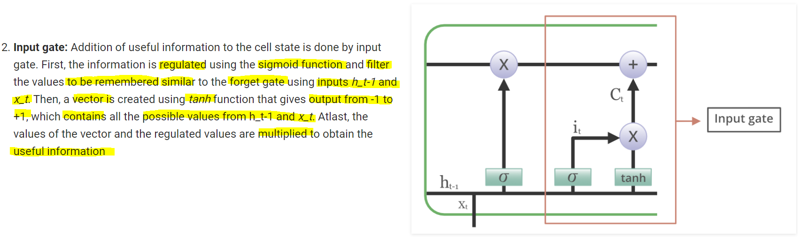

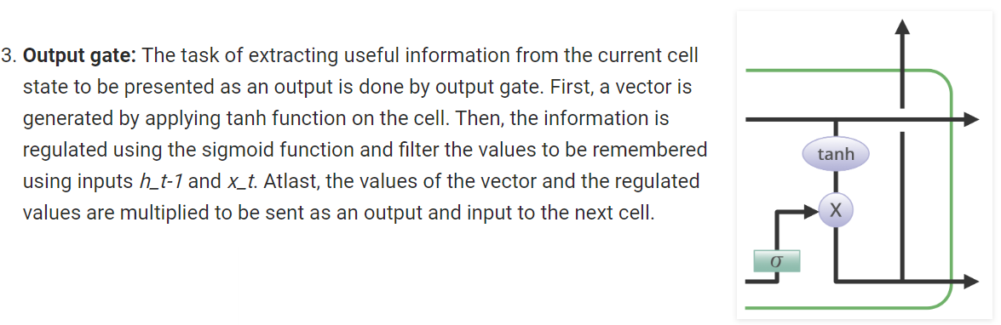

## [Medium - How LSTM networks solve the problem of vanishing gradients](https://medium.com/datadriveninvestor/how-do-lstm-networks-solve-the-problem-of-vanishing-gradients-a6784971a577)

## [Medium - The curious case of the vanishing & exploding gradient](https://medium.com/learn-love-ai/the-curious-case-of-the-vanishing-exploding-gradient-bf58ec6822eb)

## [Quora - How does LSTM help prevent the vanishing (and exploding) gradient problem in a recurrent neural network?](https://www.quora.com/How-does-LSTM-help-prevent-the-vanishing-and-exploding-gradient-problem-in-a-recurrent-neural-network)

## [StackExchange - How does LSTM prevent the vanishing gradient problem?](https://stats.stackexchange.com/questions/185639/how-does-lstm-prevent-the-vanishing-gradient-problem)

## [Blog - Why LSTMs Stop Your Gradients From Vanishing: A View from the Backwards Pass](https://weberna.github.io/blog/2017/11/15/LSTM-Vanishing-Gradients.html)

## [Exploring LSTMs](http://blog.echen.me/2017/05/30/exploring-lstms/)

## [Recurrent Neural Networks (RNN) - Long Short Term Memory ( LSTM )](https://www.superdatascience.com/blogs/recurrent-neural-networks-rnn-long-short-term-memory-lstm/)

## [Chapter 10.1: DeepNLP — LSTM (Long Short Term Memory) Networks with Math.](https://medium.com/deep-math-machine-learning-ai/chapter-10-1-deepnlp-lstm-long-short-term-memory-networks-with-math-21477f8e4235)

# When to use deep learning

## [KDnuggets – When not to use deep learning](https://www.kdnuggets.com/2017/07/when-not-use-deep-learning.html)

when the sample size is small (which happens a lot in the bio domain), linear models with few parameters perform better than deep nets even with a modicum of layers and hidden units. He goes on to show that a very simple linear predictor, with top ten most informative features, performs better than a simple deep net when trying to classify zeros and ones in the MNIST dataset using only 80 or so samples.

…

**Low-budget or low-commitment problems**

Deep nets are very flexible models, with a multitude of architecture and node types, optimizers, and regularization strategies. Depending on the application, your model might have convolutional layers (how wide? with what pooling operation?) or recurrent structure (with or without gating?); it might be really deep (hourglass, siamese, or other of the many architectures?) or with just a few hidden layers (with how many units?); it might use rectifying linear units or other activation functions; it might or might not have dropout (in what layers? with what fraction?) and the weights should probably be regularized (l1, l2, or something weirder?). This is only a partial list, there are lots of other types of nodes, connections, and even loss functions out there to try. Those are a lot of hyperparameters to tweak and architectures to explore while even training one instance of large networks can be very time consuming.

Google recently boasted that its AutoML pipeline can automatically find the best architecture, which is very impressive, but still requires more than 800 GPUs churning full time for weeks, something out of reach for almost anyone else. The point is that training deep nets carries a big cost, in both computational and debugging time. Such expense doesn’t make sense for lots of day-to-day prediction problems and the ROI of tweaking a deep net to them, even when tweaking small networks, might be too low. Even when there’s plenty of budget and commitment, there’s no reason not to try alternative methods first even as a baseline. You might be pleasantly surprised that a linear SVM is really all you needed.

**Interpreting and communicating model parameters/feature importance to a general audience**

Deep nets are also notorious for being black boxes with high predictive power but low interpretability. Even though there’s been a lot of recent tools like saliency maps and [activation differences](https://arxiv.org/abs/1704.02685) that work great for some domains, they don’t transfer completely to all applications.

**Learning from “unstructured” features**

This one might be up for debate. I find that one area in which deep learning excels at is finding useful representations of the data for a particular task. A very good illustration of this is the aforementioned word embeddings. Natural language has a rich and complex structure that can be approximated with “context-aware” networks: each word can be represented in a vector that encodes the context in which it is mostly used. …

## [TDS – Three reasons that you should NOT use deep learning](https://towardsdatascience.com/three-reasons-that-you-should-not-use-deep-learning-15bec517b622)

**(1) It doesn’t work so well with small data**

**(2) Deep Learning in practice is hard and expensive**

**(3) Deep networks are not easily interpreted**

…

## [TDS - Why Deep Learning over Traditional Machine Learning?](https://towardsdatascience.com/why-deep-learning-is-needed-over-traditional-machine-learning-1b6a99177063)

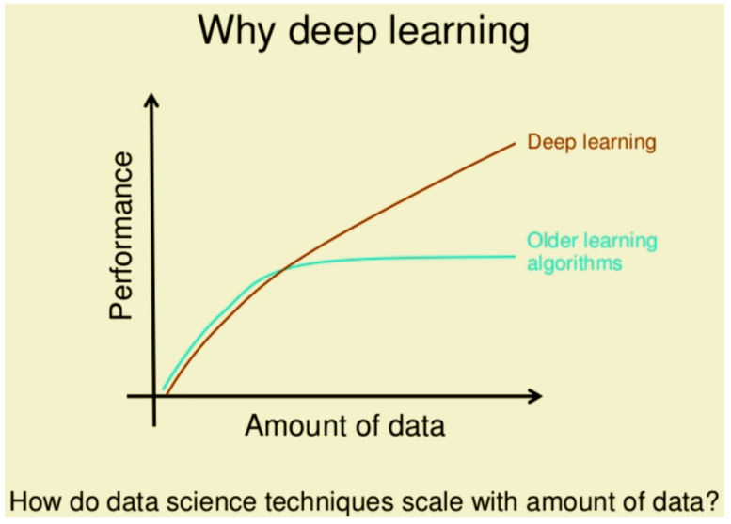

…

In traditional **Machine learning**techniques, most of the applied features need to be identified by an domain expert in order to reduce the complexity of the data and make patterns more visible to learning algorithms to work. The biggest advantage **Deep Learning** algorithms as discussed before are that they try to learn high-level features from data in an incremental manner. This eliminates the need of domain expertise and hard core feature extraction.

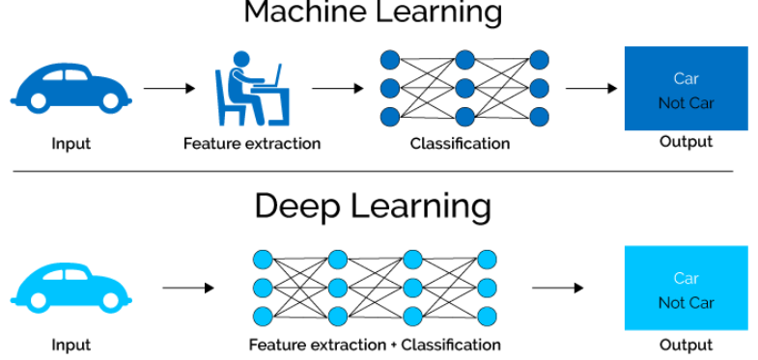

Another major difference between **Deep Learning** and **Machine Learning**technique is the problem solving approach.**Deep Learning** techniques tend to solve the problem end to end, where as **Machine learning** techniques need the problem statements to break down to different parts to be solved first and then their results to be combine at final stage. For example for a multiple object detection problem, **Deep Learning**techniques like **Yolo net t**ake the image as input and provide the location and name of objects at output. But in usual **Machine Learning**algorithms like**SVM**, a bounding box object detection algorithm is required first to identify all possible objects to have the **HOG** as input to the learning algorithm in order to recognize relevant objects.

…

Usually, a **Deep Learning** algorithm takes a long time to train due to large number of parameters. Popular **ResNet**algorithm takes about two weeks to train completely from scratch. Where as, traditional **Machine Learning** algorithms take few seconds to few hours to train.

…

Interpretability is the main issue why many sectors using other**Machine Learning**techniques over **Deep Learning**. …

**When to use Deep Learning or not over others?**

1. **Deep Learning**out perform other techniques if the ***data size is large***. But with small data size, traditional **Machine Learning** algorithms are preferable.
2. **Deep Learning** techniques need to have ***high end infrastructure*** to train in reasonable time.
3. When there is ***lack of domain understanding for feature introspection***, **Deep Learning** techniques outshines others as you have to worry less about feature engineering.
4. **Deep Learning**really shines when it comes to ***complex problems such as image classification, natural language processing, and speech recognition***.

# In Practice

## [Medium – Applying deep learning to real-world problems](https://medium.com/merantix/applying-deep-learning-to-real-world-problems-ba2d86ac5837)

# Small Additions

<https://medium.com/@purnasaigudikandula/recurrent-neural-networks-and-lstm-explained-7f51c7f6bbb9>

<https://distill.pub/2019/memorization-in-rnns/>

<https://towardsdatascience.com/recurrent-neural-networks-by-example-in-python-ffd204f99470>

<https://machinelearningmastery.com/transfer-learning-for-deep-learning/>

Transfer learning is a machine learning method where a model developed for a task is reused as the starting point for a model on a second task.

<https://towardsdatascience.com/radial-basis-functions-neural-networks-all-we-need-to-know-9a88cc053448>

In **Single Perceptron** / **Multi-layer Perceptron(MLP)**, we only have linear separability because they are composed of input and output layers(some hidden layers in MLP). For example, AND, OR functions are **linearly**-separable & XOR function is **not** linearly separable.

We atleast need **one hidden layer** to derive a non-linearity **separation**. Our RBNN what it does is, it transforms the input signal into another form, which can be then **feed** into the network to **get linear separability.**